**PERCEPTIVE CONTENT**

**BACKGROUND**

Perceptive Content is used by UJ, mainly as a document management system, but also for selection purposes. Central Academic Administration (CAA) and the Student Enrolment Centre (SEC) were forced to review the previous version of the system as we have outgrown it over the past 12 years.

The previous version had a couple of constraints making it difficult to manage applications efficiently:

* Maintenance of the system became extremely complicated as there where over 2 500 queues to be managed. The new version of the system only contains about 40 queues for system administrators to manage in the background.
* Not being able to process applications over multiple active academic years
* Not being able to do simultaneous admissions. The 2nd choice, for example, was held up in a 1st choice queue until that selection was done.
* Human error accounted for applications/folders being routed to incorrect queues.
* There was no record keeping of selection comments for audit purposes.

The new version of the Perceptive Content student application document management system does not work on a queue “pushing” format, but on a “search/filter” “pulling” format, and addresses the five main constraints experienced in the previous version mentioned above.

**COMPARISON BETWEEN THE TWO SYSTEMS**

|  |  |
| --- | --- |
| **Version 1.0** | **Version 2.0** |
| Thousands of workflow queues | No workflow queues |
| Indicated decisions in custom properties | No update in custom properties |
| No e-Form | e-Form used to indicate decisions |
| Work monitored on workflow queue level | No workflow queues |
| Data not in sync with ITS | Data from ITS updated daily |
| Choice 2 could only be processed once choice 1 was completed | Concurrent selections can be done regardless the choice of the application |
| Can only work within one application cycle | Can work with more than one application cycle e.g. 2024 for CEPs and SLPs while the curricular application cycle is already open for 2025 |
| Continuous system maintenance as each qualification needed queues and each user needed to be linked to the relevant queues | No management of queues required by system administrators. |
| Need to find applicants from a queue | Find applicants from search filters you build |
| Used “Workflow” to get to the queues | Use “Folder” to get to the applications |
| Referred to application choices as choice 1 and 2 | Referred to application choices as choice A, B, C, D until F. Applicants will be able to apply for 2 UG quals, 2 PG quals and/or 2 CEPs. |
| Various email entry points and workflows for document indexing. Curricular/HEPSA and UJ Online all separate workflows. | Combined point of indexing for curricular/HEPSA and UJ Online. |

**HOW TO INCREASE CLIENT TIMEOUT**

Make sure you are connected to Perceptive.

* Hold SHIFT in on the keyboard, and right-click at the top of the toolbar (next to your username).
* A menu appears:

Click *Open configuration file.*

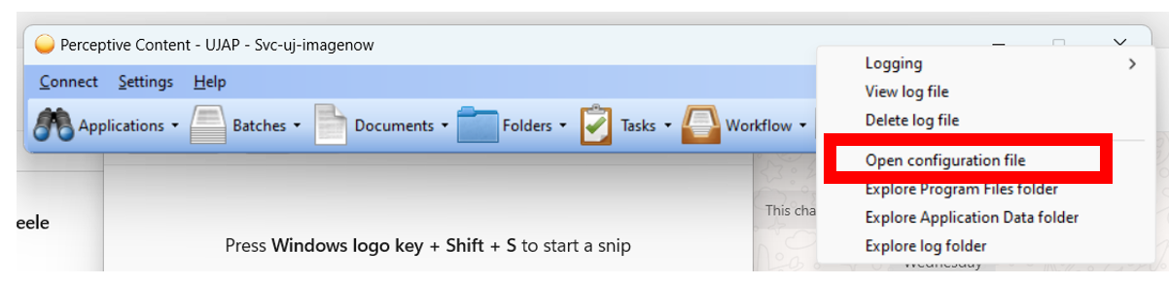

Note: An .ini file will open in Notepad (it looks like a .txt file).

* Locate the *socket.login.timeout* entry and change the value after the equal sign to *300*.
* Locate the *socket.default.timeout* entry and change the value after the equal sign to *300*.

Note: After the change the entries should look like this:

* Save and close the file.

Close Perceptive completely.

**DOCUMENT INDEXING – ONLY APPLICABLE TO BIOGRAPHIC STAFF MEMBERS**

Users must go to the *Workflow* option:

Users must then select the *Student_Application_Management* workflow option by clicking on the + sign to the right:

Depending on the responsibilities allocated to the relevant user, they will see one or more of the following queues:

Users responsible for the distribution of documents will start off by selecting the SAM01b_BIO_DocForQA workflow queue. The user can then select however many documents they want to route forward to the relevant staff member responsible for indexing.

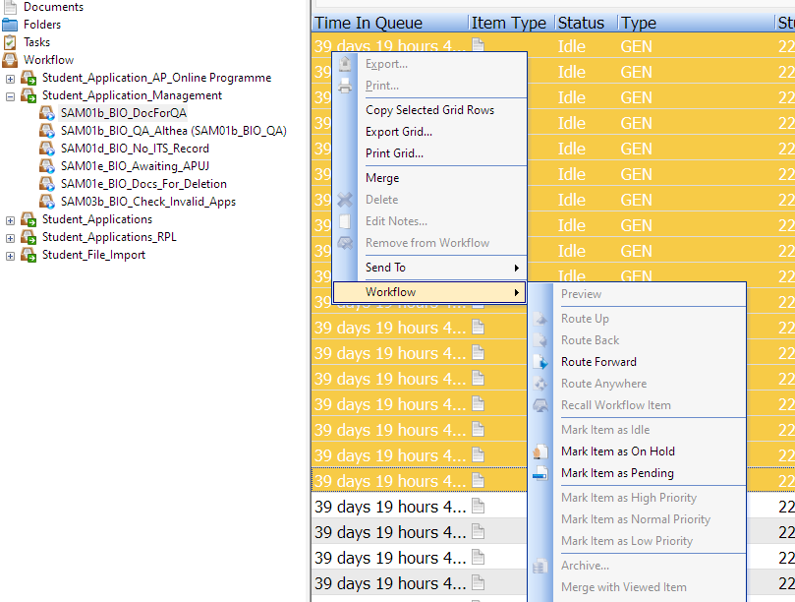

Route the documents to the relevant staff member.

Users responsible for indexing will then open the document in their respective queues.

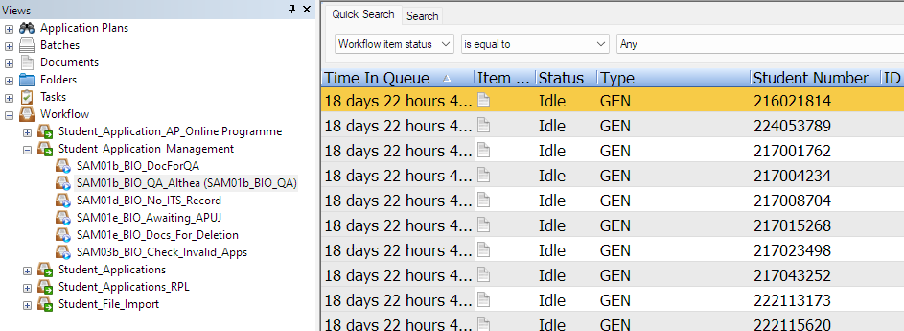

If the document is not applicable or cannot be used because it is too unclear, there are duplicates not certified the user can route the document to the *SAM01e_BIO_Docs_For_Deletion* by clicking on the route forward button at the bottom of the page.

If the document requires splitting of documents, the user can route the document to the *SAM01c_CorpGov_Splitting* by clicking on the route forward button at the bottom of the page.

If the document is identified as a document for a registered student, the user can do the normal indexing and then route the document to the *SAM01f_SYS_Trnsfr_to_RegStud* by clicking on the route forward button at the bottom of the page.

If the user cannot find an active application on ITS, the user can route the document to the *SAM01d_BIO_No_ITS_Record* by clicking on the route forward button at the bottom of the page.

If there is active record on ITS, the user must enter the relevant Student in the Custom properties and indicate the relevant document type from the dropdown list.

The user can then route the document to the *SAM01d_SYS_Send_To_Indexing* by clicking on the route forward button at the bottom of the page.

Example, applicant 224053789.

Documents as part of project/folder before indexing (Only an APUJ):

Documents as part of project/folder after indexing:

Await APUJ queue:

If, after a document is indexed, and routed forward to the *SAM01d_SYS_Send_To_Indexing* queue, and Perceptive Content cannot pick up a folder (created by an APUJ), the document will automatically be routed to the ***SAM01e_BIO_AwaitAPUJ.*** *Perceptive script will automatically check for an APUJ and route the document out of the queue as soon as the APUJ has created. If, after a month, there are still documents, the documents may be sent to the delete queue.*

Check invalid Apps queue:

Applications with incorrect academic year that needs to be changed and updated will be in the **SAM03b_BIO_Check_Invalid_Apps**.

**SELECTION PROCESS OVERVIEW**

1. Search for applicants according to your search filters.
2. Review the relevant documents.
3. Indicate the decision on the e-Form.
4. Selector/faculty officer to update ITS.

**STEP BY STEP PROCEDURE**

You need to have Perceptive Content installed on your computer. Please contact ICS if you are a new user to install the software.

Login to the system with your UJ login details.

Please note that the number of icons displayed once perceptive content opens, will differ from user to user depending on the privileges you have on the system.

You will no longer use Workflow to access the application queues. You will now use Folders.

Click on *Folders* to expand the option.

Click on *Student Application Management*.

You will see two “global” search filters already created - *“List of students 2024”* and *“List of students 2025”*. These two search filters are called “prompted” filters as it will prompt you for information. You can use these search filters to search for a list of up to 2 500 applicants at a time, for that specific academic year.

Any additional search filters you build will be added below these global search filters.

**BUILDING SEARCH FILTERS AND ACCESSING APPLICATIONS**

You can access your applications in one of two ways.

1. By using the global prompted search filter
2. Building your own search filters
3. **USINGTHE GLOBAL PROMPTED FILTER**

This filter will prompt you to enter student numbers. You can enter up to a maximum of 2 500 student numbers. When you click on, for example, *“List of students 2024”*, you will be prompted to enter student numbers. These student numbers can be drawn from various sources including a HEDA report, MS Access report or a cube report. For example, you want all applications for a specific qualification by entering a list of student numbers you got from one of the reports. Enter your list of student numbers in the student number field and click on OK.

Depending on the number of student numbers entered, it might take a while for the list to generate.

The list of applicants will appear.

Search results can be exported as a csv file by right clicking and selecting the “export grid” option from the list of values.

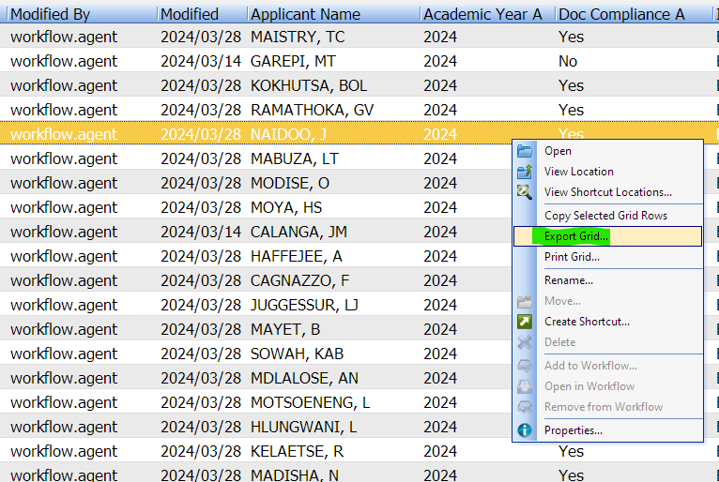

You can now open an application from the search result list.

At the top are three TABS.

The application will default to the *Forms* tab.

* 1. **TABS**
     1. **FORMS TAB**

The Form has two sections:

**Section A** - Applicant details

**Section B** - Applications according to choice A, B, C, D, E and F.

With each choice there will be an indication (if applicable) if the relevant document(s) for that specific qualification is submitted or not. In the example below, we can see that the relevant docs for choice A are submitted but not for choice B.

Locate the specific qualification you are looking for under Choice A up to F. The student numbers you have entered has an application for the specific qualification, however you don’t know if that qualification was choice A or B or C etc.

The *“Data as on ITS”* in the e-form is as currently on ITS and will refresh overnight to reflect real-time data when the form is opened the next day.

On the right-hand side of the screen is the Custom Properties, however, you are not going to make any updates here. These Custom Properties will update the daily, together with the “*Data as on ITS*” on the e-form. The data for the “Decisions” information captured on the e-form will update on the Custom Properties everytime you open and close the application.

The purpose of of the custom properties field is for search filter data to work properly. It is not compulsory for the custom properties field to be displayed. The custom properties field can be activated and de-activated by pressing the F7 button. This is however a good way to validate that the data you see on the e-form correlates with data in the custom properties. If the data is not the same, after a daily refresh, then please contact the data administrator.

**1.2.2. CONTENT TAB**

When you click on the Content TAB a list of all the submitted documents will be displayed.

You can open the document(s) for review and start the selection process.

* 1. **LOCATE THE RELEVANT CHOICE AND CAPTURE THE DECISION**

Locate the relevant choice for the specific qualification you are looking for. Once a decision has been made, the decision needs to be captured on the e-Form. Start with the *Decisions* dropdown and select the relevant application status (status category). Depending on the status you select, the following two list of values (*Reason – Declined* and *Reason – Deferred/Pending*) will be activated/de-activated. Please enter all the required activated fields with values if prompted. Comments can be made regardless of the status allocated and is therefore not activated based on the status allocated.

After the decision was saved the document is updated and the decision displayed in the decisions history. Please only click on the *Save Decision* button once as the same decision will be saved again should you click on the button twice. The latest decision will be displayed at the top in the decisions history field.

Once you are done with the application, you can close the application at the top right or click on the SAVE button at the left.

You will be prompted to save. Click on YES.

Remember there could be applications up to choice F. for example, the applicant below has four choices.

**SUMMARISED PROCEDURE**

1. Click on Folders to get to the Student Application Management folder.
2. From the Student Application Management folder, select the relevant search filter and enter search criteria when the prompted box pops up – student numbers obtained from another source.
3. Open the application from the result list.
4. Click on the *Content* tab and view relevant documents.
5. Click on the Formstab.
6. Locate the relevant choice, indicate the decision (and other details where relevant). Selectors/Faculty officers to update ITS based on the decision entered.
7. Save Folder.
8. **BUILDING YOUR OWN CUSTOM FILTERS**

Custom filters only need to be configured once.

A user can have as many filters as needed.

A user can share a filter with others, and they can edit it.

The year **AND** the block code (0, D0, O0) must always be part of the parameters (If you are not using a qualification code as a filter option)

The order of the parameters does not matter (except in search strings).

**2.1 HOW TO BUILD YOUR OWN FILTER**

You must decide exactly what it is that you want. For example, you want to build a filter to get all the applications for a specific qualification.

Go to Folders.

Stand on Student Application Management and click on *Search*

Click on the green plus sign.

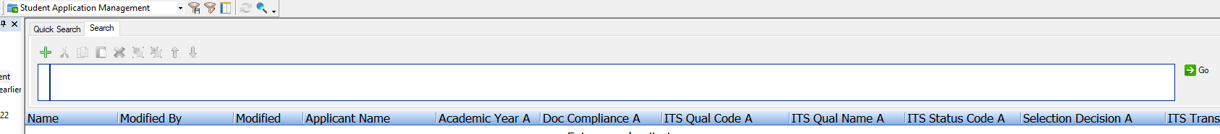

Start to build the conditions for your filter.

For example you want all the applications for a specific qualification code for 2024.

1. Always start with the year (2024)
2. Followed by the qual code (B4L03Q).

Conditions to enter:

* **Constrain by**: *Select Custom Property* from the drop-down list because you are customising the filter for yourself.
* **Type**: *Normal*
* **Field**: Select your first input parameter from the drop-down list – which will be the year *–* therefore select *Academic Year A*
* **Operator**: *is equal to*
* **Value**: Enter *2024 or 2025* (you cannot put both in)
* **Click on**: OK

Once you have clicked on OK, it will look like this.

Click on the green plus sign again and add your next parameter which will be the qualification code.

Click on OK.

Once you have clicked on OK, it will now look like this.

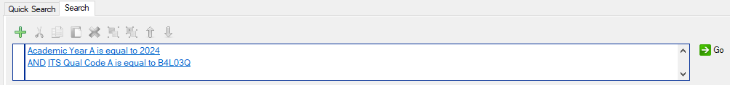

Group the two parameters together by selecting the arrow in front of a*cademic Year A is equal to 2024,* holding down the CONTROL key on your keyboard and selecting the arrow in front of *AND ITS Qual Code A is equal to B4L03Q.* Click on the group together button. There will be an **AND** between the year and the qual code as you are looking for applications that is in year 2024 and has the qual code of B4L03Q.

It will then look like below.

This now needs to be copied 5 times to make provision for any applications that might be on choice B, C, D, E or F.

Select the arrow in front of the row you want to copy.

Select the COPY button.

Select the PASTE button and click on it five times.

The parameters should now be changed to **OR** as you are looking for applications that are in choice A **OR** choice B **OR** choice C up to choice F.

This can be done just by clicking on the **AND** (It will automatically change to an **OR**).

Click on the **AND** to change it to **OR between all lines.**

Click on each separate entry field you now need to update to B,C,D,E,F.

Edit the parameters so that all the B,C,D,E,F data is in one line each.

Continue and do the rest of the lines until all of them are changed ranging from A to F.

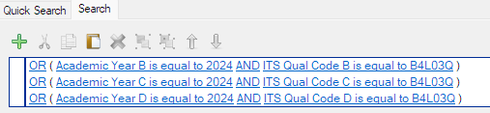

Save the Filter.



Give the filter a name and click on OK

The filter will now display with the rest of your customised filters on the left-hand side under Student Application Management.

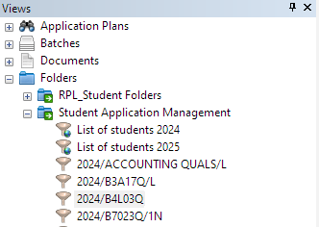

If you click on the filter, the system will automatically generate the list of applications with your specific search parameters.

If you look at the list below, it seems that not all applicants have applied for B4L03Q. In your input parameters you have requested a list of students who has applied for this qualification regardless of the choice – therefore the application might be under choice A, B, C, D, E or F.

You can now start to open the applications one by one and do the selection as per point 1.4 in training manual.

The applicant at the top is displaying Bachelor of Commerce as choice A. When you open the application you will see that the qualification you were searching for (B4L03Q) is on choice B.

* 1. **HOW TO USE YOUR SAVED SEARCH FILTERS**

When you open Perceptive Content and you select the Folders option, all the search filters you built will be displayed. Select the specific search filter and the list will automatically generate. If you want to refresh the list, you can also click on the GO button.

1. **USING A PRE-DEFINDED SEARCH STRING FILTER**

Search strings will most likely only be used by users dealing with a specific qualification and don’t want to make use of building a search filter as explained in point 2 in the manual.

For the convenience of the user, Perceptive Content has built an e-Form that users can use to create a search string.

The link to the form is - <https://webnow.uj.ac.za/imagenowforms/fs?form=UJ_SAMTool>

If you get a security warning when loading it the first time, proceed to the form.

When you click on the link, the page below will open and you ONLY NEED TO ENTERthe data for the yellow fields.

**Academic year** – select from drop down list

**Qual code** – Enter the specific qualification code

**Status code** – Enter the specific admission status code

**All docs** – Select Yes or No from the drop down list. When selecting YES, you will only see applications where there are document compliance rules applied and they have complied to those requirements.

**Faculty/Qual Level/Qual Type/Research Degree**– Will automatically be populated once qual code is entered.

Once all parameters are entered, you can click on *Create String* and the Search String will generate at the bottom of the form. The user can click on the “Copy String” button.



The user can now start building a search filter by following the steps as per point 2 in this training manual. The only difference is that now, in the *Field* dropdown, the user must select *ITS Data Summary A* and paste the string data they copied from the form. The user must then repeat the same steps as per point 2, but just change the *ITS Data Summary A* to B,C,D,E and F.

**SCENARIOS**

Please find attached a document with the most important/likely scenarios and the parameters to build to get the specific applications.



EXAMPLE: Postgraduate selection (SEC-Faculty-Department)

* SEC receives application and builds filter to distinguish between complete/incomplete applications (with or without an academic transcript – AC Document).
  + Complete (with AC document) – Referred to Faculty (RF) status allocated.
  + Incomplete (no AC document) – Postgraduate Documents Outstanding (8D) status allocated. Letter generated to request AC document from applicant. Once applicant submits document then SEC will change status from 8D to RF.
* Faculty builds filter – Year (2025) /Block (0) /Faculty (16) /Status (RF)
  + Faculty does high level selection and either decline, provisionally select, conditionally admit or admit applicant where possible.
  + If further input required from Department then Faculty changes status on ITS to

Referred to Department (RD) or Postgraduate Referred to Department (8R). Faculty can also change “Decision” on e-form to referred to department and insert comments.

* Department builds filter – Year (2025) / Department Code (1413) or Qualification code / Status (RD or 8R)
  + Department reviews application and indicates “Decision” on e-form and insert notes if required.
* Faculty builds filter - Year (2025) / Department Code (1413) or Qualification code / Status (RD or 8R)
  + Faculty sorts list according to “Decisions Column”. Changes ITS status according to decision indicated by Department.

**ADMISSION CODES AND WHEN TO USE WHICH ONE**

Please find attached a document with the admission codes and when to use which one to be used when doing selections. The use of the correct admission code is very important as there is a letter linked to the admission code. Using the incorrect admission code will result in the applicant receiving an incorrect letter.



**FACULTY CODES**

|  |  |  |
| --- | --- | --- |
| **FACULTY** | **CUR** | **E-CUR** |
| CBE | 34 | 134 |
| EDU | 51 | 57 |
| FADA | 18 |  |
| FEBE | 6 | 66 |
| HSC | 15 | 156 |
| HUM | 16 | 167 |
| JBS | 19 | 191 |
| LAW | 4 | 47 |
| SCI | 2 | 27 |
| STRAT INITIATIVES & ADMI |  | 90 |
| ADC (CEP) |  | 60 |
| UJELP |  | 60 |

**CITIZENSHIP**

South African

Permanent Resident

International

**DEPARTMENT CODES**

|  |  |
| --- | --- |
| **DEPARTMENT NAME** | **CODE** |
| Academic Dev Centre (CEP) | 6000 |
| ACADEMY COMPT SCI & SOFTW ENGI | 2109 |
| ACADEMY COMPT SCI&SOFTW ENG(CE | 2719 |
| ACCOUNTANCY (CEP) | 3711 |
| ALI MAZURI CENTRE (CEP) | 5717 |
| APPLIED INFORMATION SYST (CEP) | 1471 |
| BUSINESS MANAGEMENT (CEP) | 1472 |
| CACS | 9013 |
| CEN PUB POLICY&AFRICAN STUD | 1478 |
| CHILDHOOD EDUCATION (CEP) | 5710 |
| DEANS OFF- ENGINEERING (CEP) | 6600 |
| DEANS OFF. HUMANITIES (CEP) | 1670 |
| DEANS OFFICE - LAW (CEP) | 4710 |
| DEANS OFFICE- ART,DESIGN&ARCH | 1700 |
| DEANS OFFICE ECO & FIN SCI | 3710 |
| DEANS OFFICE- SCIENCE (CEP) | 2700 |
| DEANS OFFICE: ART,DES & ARCHI | 1800 |
| DEANS OFFICE: EDUCATION | 5100 |
| DEANS OFFICE: ENGINEERING | 6100 |
| DEANS OFFICE: HEALTH SCIENCES | 1500 |
| DEANS OFFICE: HUMANITIES | 1600 |
| DEANS OFFICE: LAW | 4100 |
| DEANS OFFICE: MANAGEMENT | 1400 |
| DEANS OFFICE: SCIENCE | 2100 |
| DEP OF ACCOUNTANCY | 3101 |
| DEP OF AFRICAN LANGUAGE | 1622 |
| DEP OF ANTHROP & DEV STUDIES | 1611 |
| DEP OF APPLIED INFORMATION SYSTEMS | 1421 |
| DEP OF ARCHITECTURE | 1802 |
| DEP OF BIOCHEMISTRY | 2103 |
| DEP OF BIOMEDICAL SCIENCES | 1531 |
| DEP OF BIOTECH AND FOOD TECH | 2146 |
| DEP OF BOT & PLANT BIO-TECHNOL | 2102 |
| DEP OF BUSINESS MANAGEMENT | 1412 |
| DEP OF CHEM ENG TECHNOLOGY | 6301 |
| DEP OF CHEMICAL SCIENCES | 2105 |
| DEP OF CHILDHOOD EDUCATION | 5107 |
| DEP OF CHIROPRACTIC | 1511 |
| DEP OF CIVIL ENGINEER SCIENCE | 6101 |
| DEP OF CIVIL ENGINEER TECH | 6102 |
| DEP OF COMM AND MEDIA STUDIES | 1632 |
| DEP OF COMMERCIAL ACCOUNTING | 3108 |
| **DEPARTMENT NAME** | **CODE** |
| DEP OF COMMERCIAL ACCOUNTING (CEP) | 3718 |
| DEP OF COMPLEMENTARY MEDICINE | 1512 |
| DEP OF CONSTRU MGT & QUANT SUR | 6103 |
| DEP OF DIGIT & COMM ENG TECHNO | 6202 |
| DEP OF ECONOMIC & ECONOMETRICS | 3104 |
| DEP OF EDU LEADERSHIP & MAN | 5101 |
| DEP OF EDUCATION&CURRICULUM ST | 5108 |
| DEP OF EDUCATIONAL PSYCHOLOGY | 5102 |
| DEP OF ELEC & ELEC ENG SCIENCE | 6203 |
| DEP OF ELECTRIC ENG TECHNOLOGY | 6206 |
| DEP OF EMERGENCY MEDICAL CARE | 1533 |
| DEP OF ENGLISH | 1625 |
| DEP OF ENVIRONMENTAL HEALTH | 1532 |
| DEP OF FASHION | 1803 |
| DEP OF FINANCE & INVEST | 3105 |
| DEP OF GEOG ENV & ENERGY STUDY | 2107 |
| DEP OF GEOG,ENV & ENERGY STUDY | 2717 |
| DEP OF GEOLOGY | 2108 |
| DEP OF GRAPHIC DESIGN | 1805 |
| DEP OF HISTORY | 1613 |
| DEP OF HOSPITALITY MAN (CEP) | 1486 |
| DEP OF HOSPITALITY MANAGEMENT | 1426 |
| DEP OF HUMAN ANATOMY&PHYSIOL | 1530 |
| DEP OF IND PSYCH&PEOPLE M(CEP) | 1473 |
| DEP OF IND PSYCHOLOGY&PEOPLE M | 1413 |
| DEP OF INDUSTRIAL DESIGN | 1806 |
| DEP OF INFO & KNOWLEDGE MGT | 1422 |
| DEP OF INTERIOR DESIGN | 1807 |
| DEP OF JBS | 1430 |
| DEP OF JBS (CEP) | 1432 |
| DEP OF JEWEL DESIGN & MANUFACT | 1808 |
| DEP OF LANG, CUL STUD&APPL LIN | 1643 |
| DEP OF LANG, CUL STUD&APPL LIN (CEP) | 1644 |
| DEP OF MARKETING MANAGEMENT | 1414 |
| DEP OF MATERNAL &CHILD NURSING | 1521 |
| DEP OF MATH & APPL MATHEMATICS | 2120 |
| DEP OF MECH ENG SCIENCE | 6303 |
| DEP OF MECH ENG SCIENCE(CEP) | 6661 |
| DEP OF MECH&IND ENG TECHNOLOGY | 6305 |
| DEP OF MEDICAL & SURG NURSING | 1522 |
| DEP OF MEDICAL IMAGING&RADIAT | 1536 |
| DEP OF MERCANTILE LAW | 4102 |
| DEP OF METALLURGY | 6405 |
| **DEPARTMENT NAME** | **CODE** |
| DEP OF MINING ENG&MINE SURVEY | 6406 |
| DEP OF MULTIMEDIA | 1809 |
| DEP OF OPTOMETRY | 1534 |
| DEP OF PHILOSOPHY | 1614 |
| DEP OF PHYSICS | 2112 |
| DEP OF PODIATRY | 1535 |
| DEP OF POLITICS (CEP) | 1691 |
| DEP OF POLITICS&INTERNAT RELAT | 1641 |
| DEP OF POLITICS&INTERNAT RELAT (CEP) | 1696 |
| DEP OF PRIVATE LAW | 4104 |
| DEP OF PROCEDURAL LAW | 4101 |
| DEP OF PROFES NURSING PRACTICE | 1523 |
| DEP OF PSYCHIATRIC NURSING | 1524 |
| DEP OF PSYCHOLOGY | 1616 |
| DEP OF PUBLIC LAW | 4105 |
| DEP OF PUBLIC MANAGE&GOVER(CEP | 1477 |
| DEP OF PUBLIC MANAGEMENT&GOVER | 1417 |
| DEP OF QUALITY & OPERATION MGT | 1423 |
| DEP OF RELIGION STUDIES | 1620 |
| DEP OF RELIGION STUDIES CEP | 1645 |
| DEP OF SCIENCE&TECHNOLOGY EDU | 5105 |
| DEP OF SOCIAL WORK&COMMUNITY D | 1617 |
| DEP OF SOCIOLOGY | 1618 |
| DEP OF SPORT&MOVEMENT STUDIES | 1540 |
| DEP OF STATISTICS | 2116 |
| DEP OF STRATEGIC COMMUNICATION | 1631 |
| DEP OF TOURISM MANAGE(CEP) | 1485 |
| DEP OF TOURISM MANAGEMENT | 1425 |
| DEP OF TRANS &SUPPLY CHAIN MGT | 1415 |
| DEP OF URBAN & REGIONAL PLAN | 6105 |
| DEP OF VISUAL ART | 1804 |
| DEP OF ZOOLOGY | 2113 |
| ECONOMICS & ECONOMETR (CEP) | 3714 |
| EDU&CURRICULUM STUDIES (CEP) | 5713 |
| EDUCATION LEAD&MANAGE (CEP) | 5711 |
| EDUCATIONAL PSYCHOLOGY (CEP) | 5712 |
| ELECTRICAL AND ELCTRONIC ENG S | 6713 |
| FINANCE (CEP) | 3715 |
| IIS | 9014 |
| INFOR BUSS MAN (CEP) | 1482 |
| IPATC | 9011 |
| JIAS | 9012 |
| MARKETING MANAGEMENT (CEP) | 1474 |
| **DEPARTMENT NAME** | **CODE** |
| MERCANTILE LAW (CEP) | 4712 |
| POST GRAD SCHOOL OF ENG MAN | 6718 |
| PUBLIC LAW (CEP) | 4715 |
| QUAL & OPERATION MAN (CEP) | 1483 |
| SCHOOL OF SCiiS | 1420 |
| SOCIAL WORK (CEP) | 1677 |
| SOCIOLOGY (CEP) | 1678 |
| TOWN AND REGIONAL PLAN. (CEP) | 6615 |
| TRANSP & SUPPLY CHAIN (CEP) | 1475 |
| UJCE-UJ CENTRE FOR ENTREPRE | 1427 |
| ZOOLOGY (CEP) | 2723 |

**QUALIFICATION TYPES**

|  |
| --- |
| Advanced Certificate |
| Advanced Diploma |
| Bachelor Honours Degree |
| Bachelor's Degree |
| Bachelor's Degree (480) |
| Bridging |
| Bridging Programme |
| Bridging Programme (NCB) |
| Community Engagement |
| Diploma |
| Diploma (240) |
| Diploma (360) |
| Diploma (Transport Only) |
| DOCTORAL DEGREE |
| Higher Certificate |
| Master's Degree |
| Master's Degree (Professional) |
| Non Degree Purposes (PG) |
| Post Graduate Certificate in E |
| POST GRADUATE OCCASIONAL |
| Postgraduate Diploma |
| POST-GRADUATE OCCASIONAL |
| Postgraduate Occasional Inter |
| PROF 1ST B DEGREE >= 4 YRS |
| Short Learning Programme |
| Short Learning Programme (NCB) |
| UNDERGRADUATE OCCASIONAL |
| Undergraduate Occasional Inter |

**DOCUMENT COMPLIANCE RULES**

|  |  |  |  |  |  |  |
| --- | --- | --- | --- | --- | --- | --- |
| **Qualification level** | **Applicant type** | **Qualification code** | **Qualification type** | **Qualification Description** | **Status Code** | **Required documents** |
| CEP | n/a | List of qualification codes | n/a | n/a | n/a | NC |
| UG | South African (N) | n/a | n/a | n/a | 1D | NC |
| RS | AC |
| RO | UJAC |
| PS | UJAC_0 |
| AO | UJAC_O0 |
| AA | UJAC_D0 |
| 7 |  |
| I |  |
| VO |  |
| V |  |
| 9N |  |
| International (Y or F) Permanent Residence (P) | 2D | NC |
|  |
| 2V | “MX” |  |
| OR “MX Letter” |  |
| OR “CX” |  |
| OR “CX Letter” |  |
| PG | n/a | n/a | Advanced Diploma Bachelor Honours Degree  Bridging Programme (NCB) DOCTOR TECHNOLOGY DEGREE DOCTORAL DEGREE Doctoral Degree (Professional) HONOURS DEGREE MAGISTER TECHNOLOGY DEGREE Master's Degree Master's Degree (Professional) POST-GRADUATE DIPLOMA OR CERT. POST-GRADUATE B DEGREE Post Graduate Certificate in E Postgraduate Diploma BACCALAUREUS TECHNOLOGY DEGREE Non Degree Purposes (PG) POST-GRADUATE OCCASIONAL Postgraduate Occasional Inter POST GRADUATE OCCASIONAL | n/a | n/a | AC |  |
| UJAC |  |
| UJAC_0 |  |
| UJAC_O0 |  |
| UJAC_D0 |  |

**WHAT TO SELECT WHEN YOU ARE LOOKING FOR A SPECIFIC PARAMETER TO BUILD A SEARCH FILTER:**

|  |  |  |
| --- | --- | --- |
| **PARAMETER REQUIRED** | **PARAMETER NAME ON PERCEPTIVE** | **DATA** |
| Admission Status | ITS Status Code A-F | As per training manual |
| All documents submitted | Doc Compliance A-F | Yes/No (Updates every 8 hours) |
| Block Code | ITS Block Code A-F | 0, O0, D0 |
| Citizenship | Citizenship | As per training manual |
| Department | ITS Department Code A-F | As per training manual |
| Faculty | Faculty Code A-F | As per training manual |
| Offering Type | Offering Type A-F | As linked per qualification |
| Qualification Code | ITS Qual Code A-F | As on academic structure on ITS |
| Qualification level | Qual Level A-F | PG/UG/CEP |
| Qualification name | ITS Qual Name A-F | As on academic structure on ITS |
| Qualification type | ITS Qual Type A-F | As per training manual |
| Selection decision | Selection Decision A-F | Yes/No |
| Year | Academic Year A-F | Year |
| Strings | ITS Data Summary A-F | As per string |