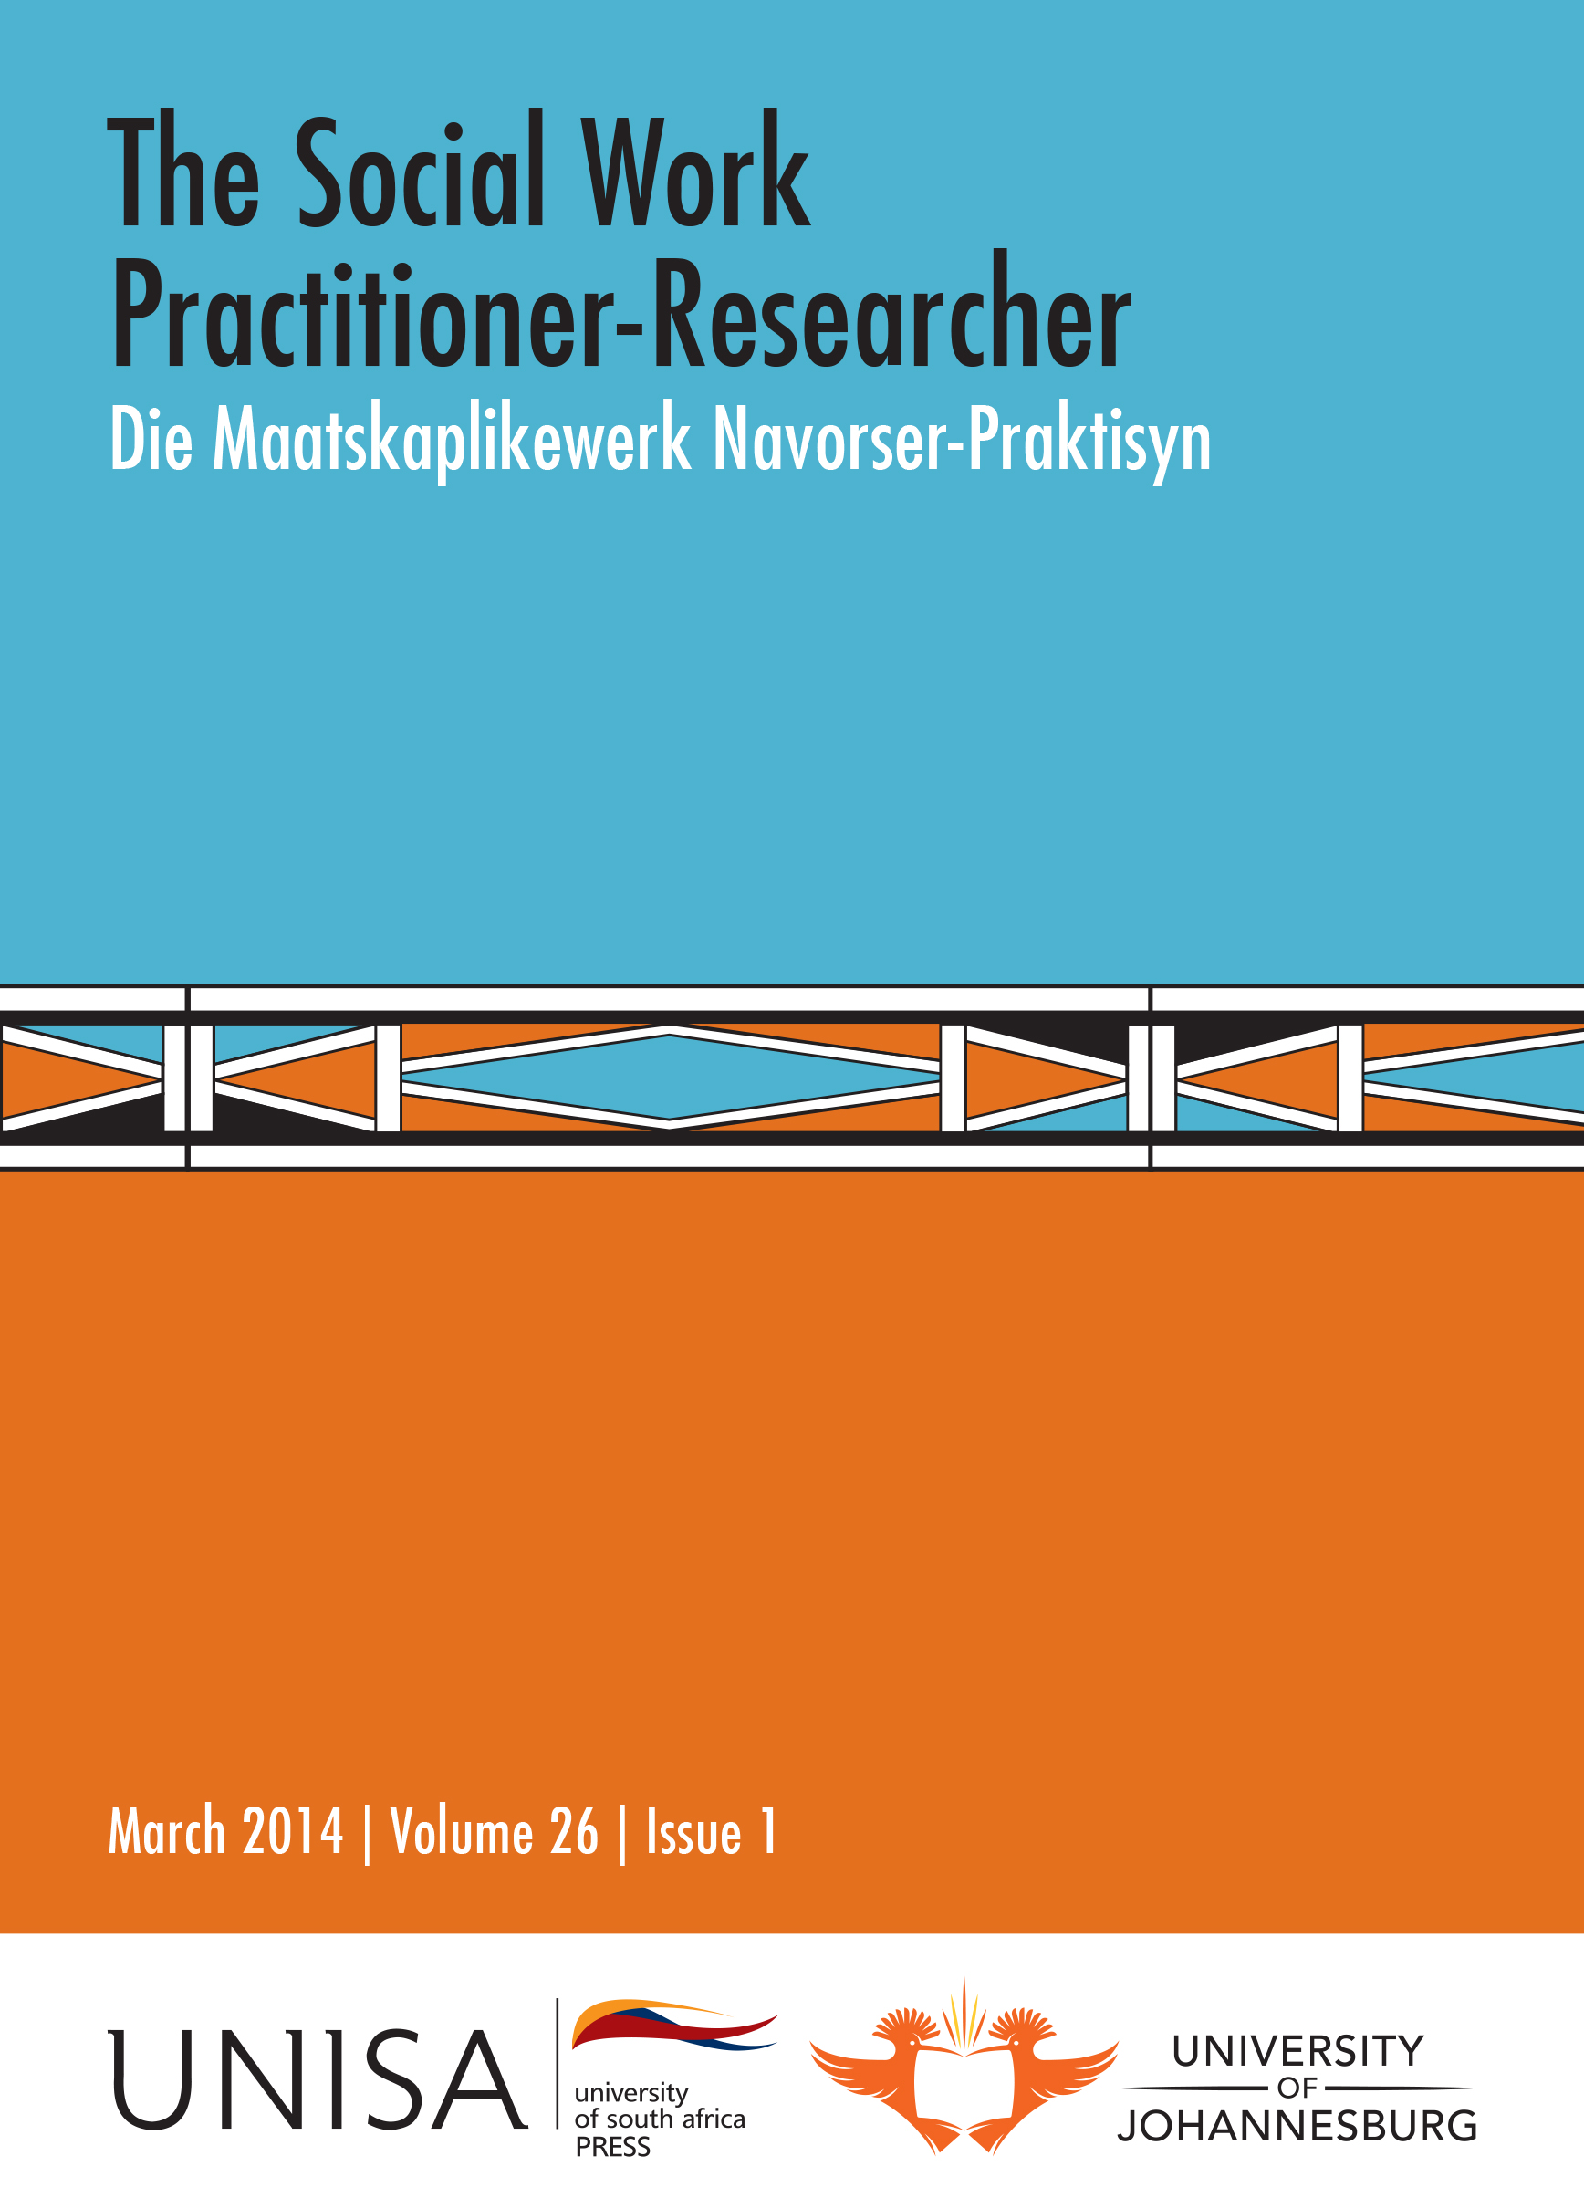 | The Social Work Practitioner-Researcher  Die Maatskaplikewerk Navorser-Praktisyn  Editor: Prof Jean Triegaardt, University of Johannesburg  Hosted by the Department of Social Work, University of Johannesburg  Published by Unisa Press  ISSN: 1011-2324

Previous Issues

March 2014, Volume 26, Issue 1

Editorial (pages 1-3)
Jean Triegaardt

The effect of a leadership development programme on a group of adolescents from a resource-restricted community (pages 4-23)
Elzahne Simeon, Alida Herbst and Alida Nienaber
The Student Rag Community Service (SRCS) of the North-West University’s Potchefstroom campus is a student-driven, registered, non-profit organisation which plans and manages more than 75 student community engagement projects. One of these projects involves a leadership development programme, Pick-A-Leader (PAL), among the grade 11 learners of three schools in resource-restricted communities in the Potchefstroom district. This article focuses on the experiences of the grade 11 learners who took part in this programme.

Adolescents’ right to participate during statutory intervention (pages 24-41)
Rina Delport and Gloudien Spies
Social work practice remains concerned about the widespread human rights abuses and the exclusion of children’s voices during statutory intervention. As stipulated by The United Nations Convention on the Rights of the Child (1994), confirmed by The African Charter on the Rights and Welfare of the Child (1999) and the Children’s Act (Section 10, 38 of 2005), it is of paramount importance that the child, which includes the adolescent, must experience freedom of expression as well as the right to be heard during statutory proceedings. However, it is argued that despite the national and international focus on the importance of child participation, the question remains if children do understand and receive the opportunity to participate in practise. This article reflects on adolescents’ understanding and experiences of their right to participate during statutory intervention.

Reasons that deter qualifying primary caregivers from applying for child support grants
(pages 42-54)

Mangalane du Toit and Liezel Lues
The Child Support Grant (CSG) came about as a strategy to address child poverty in South Africa, granted to caregivers that care for children up to the age of eighteen years. In 2012, the number of children aged up to 18 years receiving the CSG stood at 11 306 024, an increase from 800 476 in 2001. Despite amending the Social Assistance Act, 2004 (Act 13 of 2004), and numerous marketing campaigns conducted by the South African Social Security Agency (SASSA) since 2009 in the Northern Cape Region, SASSA struggles to meet the annual projected targets for CSG intakes.
An empirical study to investigate the reasons that deter primary caregivers from applying for child support was conducted in the Northern Cape. In this study, it was hypothesised that amending the criteria for CSG will increase the number of qualifying primary caregivers applying for the CSG, and assist the Frances Baard District Municipality in achieving the annual projected targets.

Social businesses as a tool and approach for youth development in sub-Saharan Africa (pages 55-73)
Grey Magaiza and Elsa Crause
Demographic transitions in sub-Saharan Africa, characterised by a youth bulge, are contextually enabling for social work professionals to investigate new methodologies of youth development. Social business is a suggested innovation of youth development with the capacity to strengthen existing social work strategies and interventions. This paper highlights the discourse on social businesses as viable development tools and approaches capable of impacting positively on youth development. Furthermore, the highlighted connections between social businesses and social work professionals may galvanise the profession to become involved in social businesses. The involvement of social work may expand the scope of community development strategies critical to tapping into the social capacities of youth. We argue that social businesses are an asset based approach representing a human face that social work can broker among communities, industry and policy makers, harnessing humanised free market capitalism to foster inclusion and expansion of livelihood options for young people.

Reflexivity in a university participatory research project in transitioning South Africa (pages 74-92)

Kathleen Collins
This article reflexively describes the influence of bias on the interaction between facilitators and participants in a participatory research project at the University of the Western Cape, South Africa. The bias uncovers racial power hierarchies in one small group which are represented in the wider context of the country in contradiction to the formally espoused democracy, in existence for nearly two decades. The author argues that biases of power are generally unrecognised in dialogue and promote the inequities which can be recognised in the legacy of apartheid. Identification of such biases is key to transforming society in South Africa.

Batterer risk assessment: The missing link in breaking the cycle of interpersonal violence
(pages 93-116)

Marcel Londt
Batterers exposed to childhood violence, with a history of violent behaviour, are impulsive, have poor anger management skills, will use intimate violence in their relationships and ignore/violate protection orders. In this study, 53 male and 47 female respondents were selected using purposive sampling. The outcome highlighted the need for treatment providers to assess ‘risk factors’ of batterers prior to any intervention. The results showed that batterers presenting with specific risk factors, posed significant risks to their intimate partners. Risk assessment and risk markers could therefore contribute to highlighting and addressing violent masculinity aspects, responsive to intervention. This approach could protect partners and encourage batterers to take responsibility for changing their abusive responses in intimate relationships. The methodological framework of this research project was informed by the Intervention Research: Design and Development. The author used a Canadian Risk Assessment Tool, the Spousal Assault Risk Assessment guide (SARA), a 20 item data collecting instrument used to ‘assess risk’ and ‘predict dangerousness’ of continued violence in men with a history of domestic/intimate violence.



