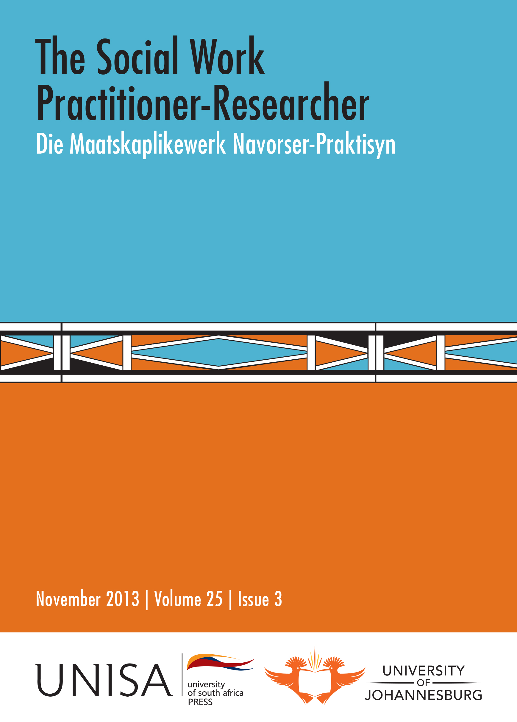 | The Social Work Practitioner-Researcher  Die Maatskaplikewerk Navorser-Praktisyn  Editor: Prof Jean Triegaardt, University of Johannesburg  Assistant Editor: Prof Kathleen Collins, University of Johannesburg  Hosted by the Department of Social Work, University of Johannesburg  Published by Unisa Press  ISSN: 1011-2324

Previous Issues

November 2013, Volume 25, Issue 3

Editorial (pages 233-235)
Jean Triegaardt and Kathleen Collins

The family’s protection of young children from sexual abuse (pages 236-253)

Maria Liggett and Madhu Kasiram
This article is based on research that investigated families’ protection of young children from sexual abuse. The perspective of families and the community was ascertained through qualitative research, conducted in the tribal area of KwaNzimakwe in KwaZulu-Natal in 2012.
Key findings were that there was mistrust in the child protection system by the family and community that exacerbated its hidden nature, that families failed to adequately respond to child sexual abuse due to misconceptions and secrecy and that absence of men and adults in the lives of children weakened families’ protection of children from sexual abuse. It was also found that indigenous community leaders played an important role in either hindering or strengthening families’ protection of children. Prevention strategies to address misconceptions and secrecy and timeous reporting of incidences of child sexual abuse were among the key recommendations made in the study.

Easing the task of social workers: Recent developments in the law on foster care for abandoned and orphaned children (pages 254-266)
Carmel Matthias and Noel Zaal
Subsection 150(1)(a) of the Children's Act 38 of 2005 states that a child may be found in need of care and protection “if, the child has been abandoned or orphaned and is without any visible means of support”. It will be shown that interpretations of this ground by magistrates have caused serious difficulties for social workers involved in finding suitable foster parents for abandoned and orphaned children. And further, application of the ground by children's courts has caused considerable hardship for many children. In two recent cases, the High Court has attempted to address these problems. In this article, by means of textual analysis and reference to relevant literature, we provide an assessment of these cases and an analysis of their important implications for social workers.

Female adolescents’ perceptions of parent-adolescent communication and sexual risk-taking behaviours (pages 267-285)

Zhaohua Wang and Abraham Greeff
The aim of this study was to investigate the relationship between parent-adolescent communication and adolescents’ sexual risk-taking behaviour. Data were obtained from 95 female adolescents, who completed self-report questionnaires when attending family planning facilities in the Cape Town metropole region of the Western Cape Province, South Africa. Family environment characteristics, especially the parents’ marital status, were significantly correlated with both parent-adolescent communication and sexual risk-taking behaviour. Also, significant correlations were found between aspects of both general and sexual parent-adolescent communication. The findings can be implemented in the development of intervention programmes aimed at decreasing sexual risk-taking behaviour among sexually active adolescents.

The relationship between services and resilience: A study of Sesotho-speaking youths
(pages 286-308)

Angelique van Rensburg, Linda Theron, Sebastiaan Rothmann and Ansie Kitching
Serious concerns are being raised about the well-being of South Africa’s young people. This article uses the Pathways to Resilience Youth Measure to examine the relationship between services and resilience through a quantitative cross-sectional study of 1,209 Sesotho-speaking adolescents. The results indicate that no positive correlations exist between resilience and service use, but there are significant negative correlations between resilience and participants who had been in foster homes, questioned by the police, in jail, on probation, or had made use of substance abuse or addiction services. Strong correlations exist between service use satisfaction and resilience. We conclude that young people’s satisfaction with the services used and not the mere fact of service use might support resilience. This has implications for social workers, including the need to nurture youth agency and healthy practitioner–youth bonds, and to shape communities towards providing constructive contexts where mandatory services are less necessary.

The SASPER: A tool to assess student social workers’ performance during field placements
(pages 309-332)
Mike L. Weyers
Even though workplace learning/field education is the signature pedagogy of social work, there are still very few standardised instruments that can be used to measure student social worker’s performance during their completion of this component of social work education. This is especially the case in South Africa. The Schedule for the Assessment of Student Performance (SASPER) was specifically developed to address this local need.
The SASPER has been in use at one of the South African higher education institutions for more than 20 years and was recently updated and re-verified. Over the years it has proved to be an excellent profiling and measurement tool that could be used for both formative and summative assessments. The latest edition covers a relative large number of competencies, traits and indicators that can be used as a tool to pinpoint a student’s individual strengths and weaknesses and to guide appropriate student development endeavours.

Social protection for retired mine workers with physical disability in Maseru, Lesotho (pages 333-349)

Thuso Tlhaole and Edwell Kaseke
The mining industry in South Africa has been a major source of employment for Lesotho men. However, some of the mine workers sustain permanent injuries and are forced to retire and thus return to Lesotho. Injured mine workers receive compensation under South Africa’s Compensation for Occupational Injuries and Diseases Act. Using a qualitative research approach, the study sought to examine the social protection arrangements for mine workers who retired on account of work-related injuries. The study revealed that most participants considered the compensation to be inadequate and that there was a long waiting period before their claims for compensation were processed. Consequently, most of the participants depended on other social support systems. Social protection is anchored within the modernisation theory which requires individuals to contribute towards their own social protection with the state only assisting those unable to help themselves.

Stokvels as livelihood strategy for women living in urban townships: Lessons from South Africa (pages 350-367)

Victor Chikadzi and Thakasile Lusenga
Despite the prevalence of stokvels as a prominent survival strategy amongst the poor, their value remains largely obscure to social work and social development given the conspicuous absence of research on this phenomenon by social work practitioners and academics. Drawing on primary qualitative data, this article examines the benefits of stokvels as a livelihood strategy for women living in townships surrounding Johannesburg in South Africa. The results of the study show that women derive a myriad of economic and social benefits by participating in stokvels. At an economic level, many poor women are managing to transition from living on the margins of the mainstream economy into becoming active participants in the productive economy owing to their participation in stokvels. Socially, stokvels have become a critical vehicle through which women form long lasting mutually beneficial ties with one another. These ties create a social capital base that women can tap into in times of adversity.



