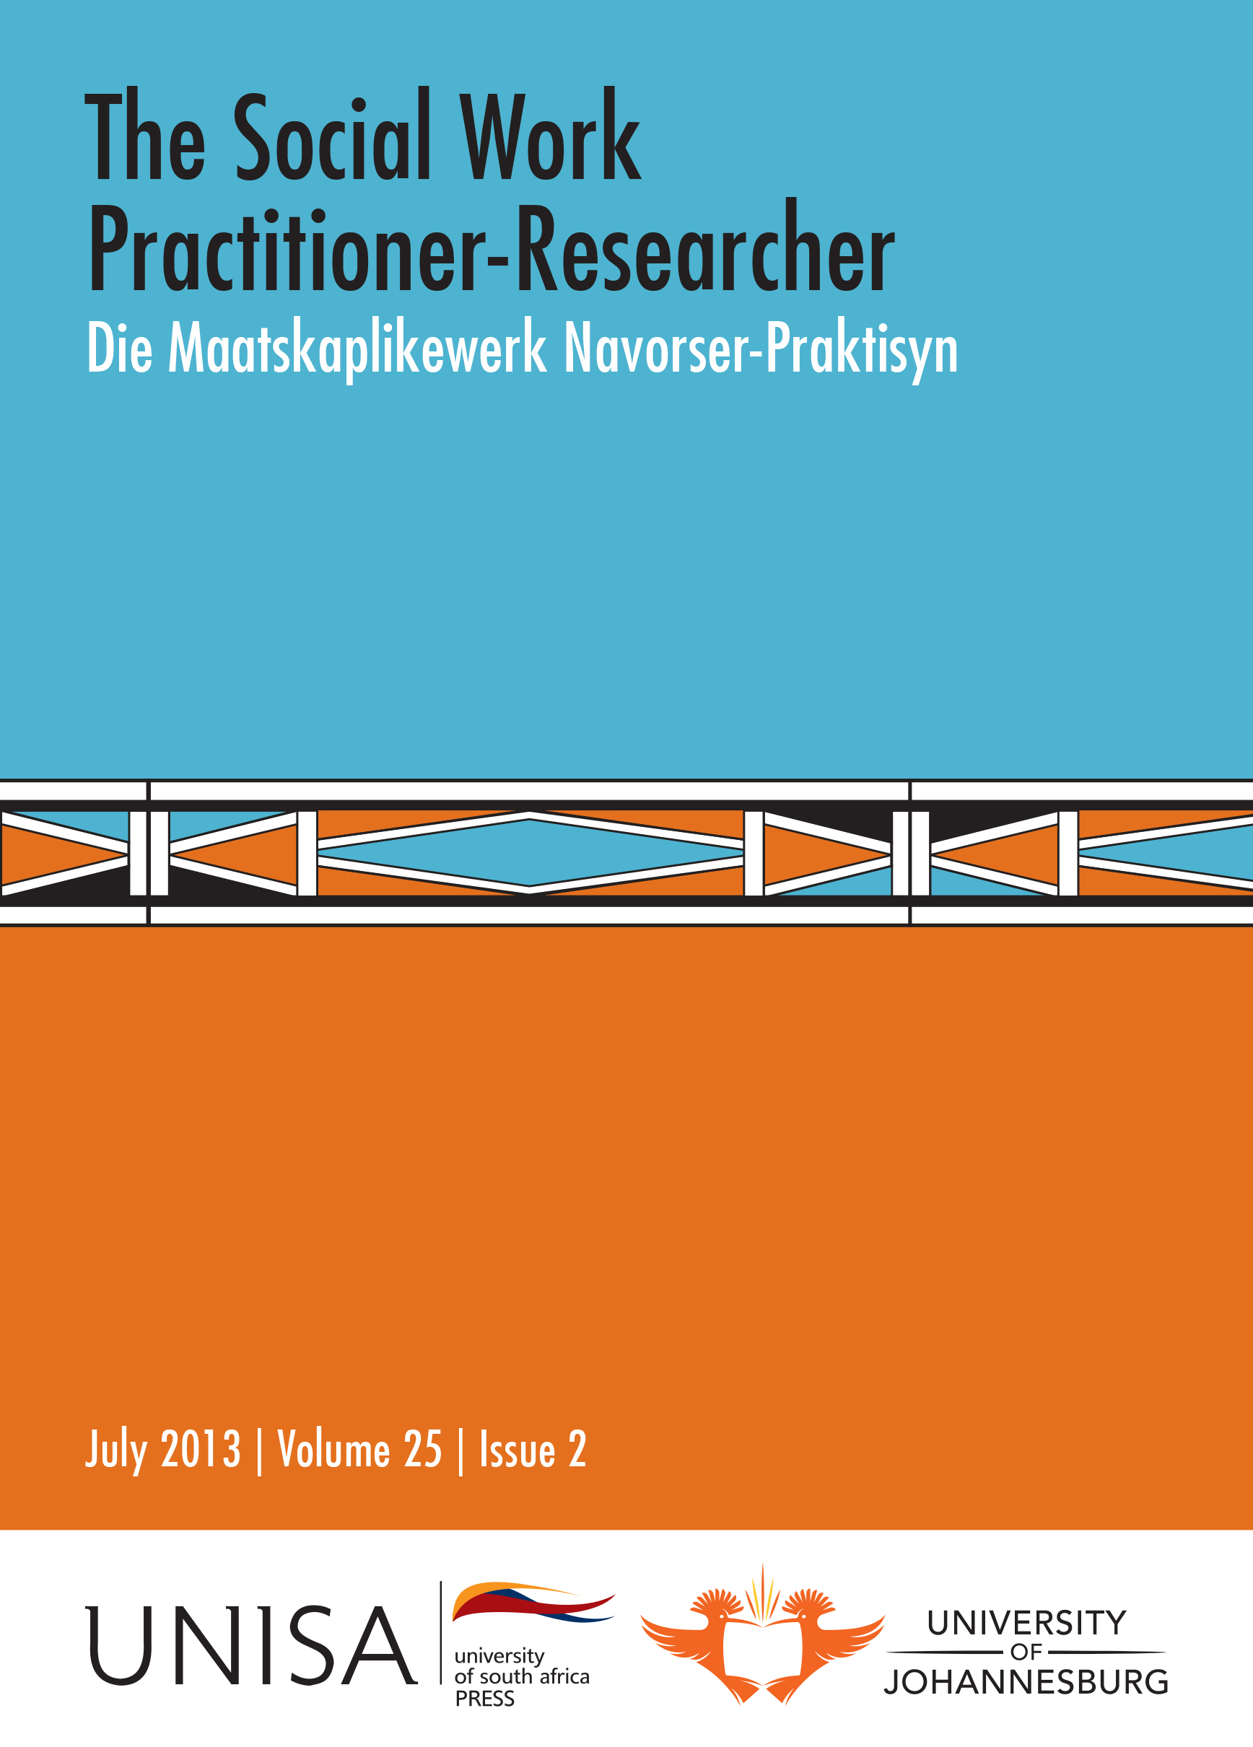 | The Social Work Practitioner-Researcher  Die Maatskaplikewerk Navorser-Praktisyn  Editor: Prof Jean Triegaardt, University of Johannesburg  Assistant Editor: Prof Kathleen Collins, University of Johannesburg  Hosted by the Department of Social Work, University of Johannesburg  Published by Unisa Press  ISSN: 1011-2324

Previous Issues

July 2013, Volume 25, Issue 2

Editorial (pages 117-119)
Jean Triegaardt and Kathleen Collins

Adolescent girls’ experience of termination in a community-based intervention (pages 120-135)
Mario Smith, Sherine van Wyk and Lidia Alkana
In response to a request from a low socio-economic community in the Winelands, the Girls’ Programme was established. The eighteen-month life skills programme facilitated participants’ transition into adolescence by equipping them with skills to negotiate the challenges of adolescence. Termination from the programme culminated in a graduation ceremony. The graduates returned to join the new intake at the commencement of the second cycle. This study attempted to understand the graduates’ motivations for returning to the programme and their experiences of termination/ graduation processes from the programme. It incorporated a qualitative methodology and used a semi-structured interview to gain insight into the graduates’ response. Thematic analysis was used to analyse the data. The results suggest that traditional conceptualisations of termination could translate into significant losses for participants in resource-poor environments. This paper elucidates those losses and makes recommendations for conceptualising termination in community interventions in resource poor communities by allied health practitioners.

Toward a risk assessment framework of child sexual offenders (pages 136-154)
Shaheda Omar and Leila Patel
Despite legislative requirements that developmental assessments be conducted with children in conflict with the law, there is no risk assessment framework to guide intervention, planning and appropriate sentencing of such children. This article draws on data derived from a mixed methods study on child-on-child sex offending. Risk assessment tools were used to evaluate the risk of children re-offending in the future. Different results were derived from the two data sources which may be due to a number of factors including limitations of the tools and the in-depth nature of information available to the social worker at the time of the assessment. This suggests that more rigorous risk assessment methods and protocols are needed that are holistic and strengths-based. This is crucial to devising appropriate intervention plans, decision making about sentencing options for young offenders, and to reduce the risk of re-offending in the future. Some pointers are provided for risk assessment.

School-going adolescents’ perceptions of interpersonal violence: A qualitative analysis
(pages 155-172)
Nirmala Gopal and Steven Collings
The aim of this study was to obtain an emic perspective on the nature, impact, and dynamics of interpersonal violence in a rural sample of South African school-going adolescents. Focus groups and focused interviews were used to explore participants’ experiences of interpersonal violence, the impact of such exposure, and factors associated with vulnerable versus resilient outcomes. Study findings indicated that all participants had been exposed to violence occurring at home, in the community and/or at school; with there being marked individual differences in the impact of such exposure on academic performance; and with more resilient outcomes being associated with higher levels of perceived social support. Thematic analysis of responses indicated that codes of ‘successful’ masculinity appear to play an important role in initiating and sustaining violence. These findings are discussed in terms of their implications for primary prevention and for future research.

Sense of belonging in children from fractured families in disadvantaged communities
(pages 173-190)
Iralda Oelofsen and Herman Grobler
A sense of belonging is important in order to form and maintain meaningful relationships later in life. This article focuses on the perceptions of children in their middle childhood from fractured families in disadvantaged communities regarding a sense of belonging, as well as the perceptions of their caregivers and social workers who work in the area. An exploratory qualitative approach, utilising the Design and Develop Model of intervention research, was followed. The population was restricted to the northern city areas of Port Elizabeth. Non-probability, purposive sampling was applied. The results suggest that there is a need for a sense of belonging with the children and that the caregivers are not always able to support this need. Social workers realise this need but need guidelines in order to support the children and caregivers.

Attitudes and experiences regarding employees with intellectual disability (pages 191-209)
Mariana de Jager and Retha Stofberg
During the 20th century, people with intellectual disability were often segregated from the community and only few were employed in the private and public sectors. Research findings show that employers’ attitudes, myths, misconceptions and apprehensions concerning persons with disability may contribute largely to the low employment rate.
A qualitative study was conducted to explore and describe employers’ attitudes and experiences regarding employees with intellectual disability. Data were collected by means of individual, semi-structured interviews. Purposive sampling was used to access 11 participants at companies who employed persons with intellectual disability. Data were analysed according to the eight steps of Tesch (1990) (in Creswell, 2003) and categorised into themes and sub-themes. The employers related positive experiences, but they also faced challenges pertaining to employees’ limited conceptual, social and practical skills, as well as family interference. These findings may be used as guidelines for employers and professionals working with persons with intellectual disability.

Geriatric end-of-life care: Developing a protocol for a South African frail care centre (pages 210-229)
Alida Herbst and Herman Strydom
This article reports on a study on the development of a protocol for geriatric end-of-life care (GEOLC) in a South African frail care centre. Participatory action research (PAR) was used as the research model for this study which recognises the active involvement and expertise of the respondents. This study involved two phases and this article focuses on phase one regarding the situation- and need analysis. This was done by way of an extensive literature study and a workshop with 32 members of the multi-disciplinary team of a South African frail care centre. Multi-method research was done by means of quantitative (a survey) and qualitative (a focus group) research procedures. Geriatric EOLC involves various moral and ethical dilemmas necessitating open discussion of the topic. This study aims to supply guidelines for the development of such a protocol through consultation with essential role players against the background of South African legislation and ethical conduct.



