Thriving in retail in the world of e-commerce

Overview

The global impact of technology has been nothing short of enormous. There is no facet of life that has not been touched by technological developments in recent years. Technology has impacted every aspect, from education to the medical field, travel, food, logistics; and banking, among many others (Wardynski, 2019). The retail sector has not escaped this phenomenon either. Online shopping is just one aspect of developments in technology, and it is changing how industries choose to merge traditional operations with new methods of trading.

This paper argues for an integrated approach to seamless e-commerce retailing.

More retailers are coming to understand that, to reach their broader customer base, there needs to be an accelerated effort to develop strategies to reach clients both online and offline (International Data Corporation, 2019). E-commerce now extends further than online stores and payment gateways. Although offline transactions still represent a large part of retail, experts such as Debajyoti (author of Strategic issues for a successful e-commerce) shares some broad ideas about how retailers can implement successful e-commerce strategies.

Strategies worth exploring

Customer experience. Retail consumers are constantly on the lookout for better alternatives. Alternative pricing. Alternative availability. And alternative experiences. This holds true especially on online platforms. Retailers must make sure that basics such as the optimisation of their websites, high quality photographs, and site navigation are up to scratch. In this visual world, the online experience should be as close to real as possible.

Cart abandonment. Just as quickly as customers can enter your website, so can they exit – without buying anything! Research estimates that at least 69% of all e-shoppers abandon their carts (Cart & Checkout UX, n.d). This means that six out of every ten visitors to an e-commerce site will leave without completing the process through to check-out, which translates to six lost sales. Online shoppers cite several reasons for deserting their carts. Top of the list is cost. Apart from the actual price of an item, shoppers are usually disappointed by having to pay extra costs, such as shipping. Retailers must reduce the cost of getting the product to the customer, along with offering different payment options, improving how efficiently the payment gateways process transactions, reducing the time it takes to transition to the next page, and improving expected delivery dates.

Experience-based commerce. Predictive engagement, or experience-based commerce, may seem nearly impossible; but it provides the highest degree of personalised interaction between retailers and their current and potential customers. Predictive engagement uses artificial intelligence to help retailers deliver relevant content to customers.

When a retailer has a combination of location, real-time behaviour, available inventory, and competitive pricing – in full awareness of the demonstrated preferences of the customer – they show predictive engagement; and that drives intelligent interactions with the customer.

Conversational commerce platforms – Integrate the socials. The shift in approach, in recent years has been from a product focus to a customer focus. People are not robots. As much as they might indulge in the convenience of doing a full transaction online, they also want the assurance that there is a human element at the other end of the line. Using mobile and web-integrated solutions enables the customer to navigate their way through your product offering in real time.

Live chats – Customers want timely responses to their queries. Live chats provide one of the fastest ways to respond to these queries, which then translates into client loyalty and satisfaction. Rich communications technologies are available to embed chat, voice, video, and screen-sharing directly within web pages and mobile applications.

Social media – Not only can social media platforms be used to build brand awareness, attract online followers, and generate online sales, but retailers can also use social media to talk directly with the customer.

Demand-driven supply
An aspect that is often overlooked in digital commerce is the balance between the available supply and the actual demands of the market. Where previously a customer would have to visit a physical store in person just to confirm the availability of some items, retailers now have the opportunity to provide accurate information. They can let customers know immediately, on the product page, whether an item is in stock, or what the backorder date is. They should also make sure that the client is informed in good time about stock being or becoming available, and their delivery options.

An easy way to frustrate a customer is to let them go through the task of finding the exact item they need on your website (or on another platform), getting ready to check-out, only to find that the item has been discontinued or is not available anymore. Take advantage of the fast-paced nature of e-commerce to communicate with your customers!

Basic framework for seamless e-commerce
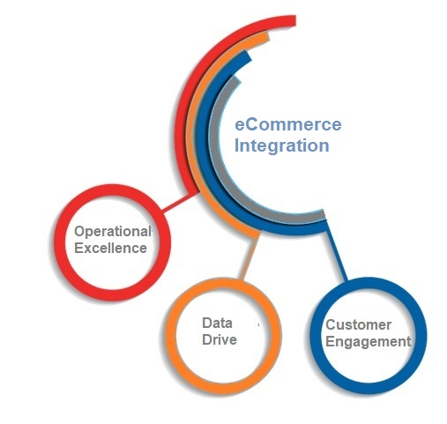
Data-centred commerce
All of the activities described as taking place in technological settings rely on common data phases. The sourcing of data, managing and refining the data for intelligent use, defining the digital parameters, and applying all these aspects to understand the past and predict the future puts the company on a good footing to understand the digital landscape within with they operate better.

Customer engagement
Retailers who consider customers to be at the centre of their strategy and process design are winning! They ensure synchronicity between their business model, the expectations and preferences of their customers, and the future business that could arise from these interactions. Indirectly, they build trust, thus delivering greater value and developing sustainable loyalty in the long term.

Operational excellence
Applying data-driven strategies and decision-making allows businesses to make the best of every opportunity. Insightful processes will certainly improve their problem-solving and yield high-quality output. As a retailer, consider the logistics and the turnaround times for delivery, and think about creating strategies to achieve same-day deliveries, for instance.

The future?
Consumer behaviours and expectations were already following a renewed trend towards going digital when the advent of the global disruption of the Covid-19 pandemic thrust this trend into acceleration mode. Businesses that can be innovative and that seize the digital opportunities that are available will emerge more relevant and more powerful.

Retailers who can get this mix right are those who will view their efforts as an investment in their digital transformation roadmap, and not just as a modern-day fad. This is not at all to say that physical stores have lost their relevance. Rather, it highlights the need for retailers to adopt new technical solutions that will help them to manage the progression to models that harmonise their physical stores with their virtual stores.

The take-home
This paper has outlined an approach to improve gradually a retailer’s efforts to transition into the digital space and to make it work, while remaining relevant to its customers.
- E-commerce will be a big part of retail operations and is here for the long haul. It will be only to every retailer’s benefit to invest in the tools they need to digitise their trade.
- Prioritise data management. Leverage available data strategies to understand better what the customer wants.
- Convenience should at the top of the list, whatever solution is provided.
- Drive positive change and satisfaction.
- Keep the customer at the centre of your planning.

Sources:
Duke, J. The future of retail insight: Artificial intelligence and attributes of everything that matters. International Data Corporation. 2019. Available at: https://www.infor.com/resources/idc-retail-insights-with-ai [Accessed on 19 July 2021]

Cart & Checkout UX. n.d. Available at: https://baymard.com/research/checkout-usability [Accessed on 28 July 2021]

Wardynski, D.J. Technology and society: How technology changed our lives. 2019. Available at: https://www.brainspire.com/blog/technology-and-society-how-technology-changed-our-lives. [Accessed on 8 July 2021]

Coppola, D. E-commerce worldwide - Statistics & facts. 2021. Available at:
https://www.statista.com/topics/871/online-hopping/ [Accessed on 28 July 2021]

Debajyoti, M. & Mishra, S. Strategic issues for a successful e-commerce. Computing Research Repository – CORR. 2011. Available at: https://www.researchgate.net/publication/48200865_Strategic_Issues_For_A_Successful_E-Commerce [Accessed on 20 July 2021)

