INTERPRETATION OF THE 25% (JOURNALS) AND 40% (PROCEEDINGS) AUTHORSHIP CLAIMS

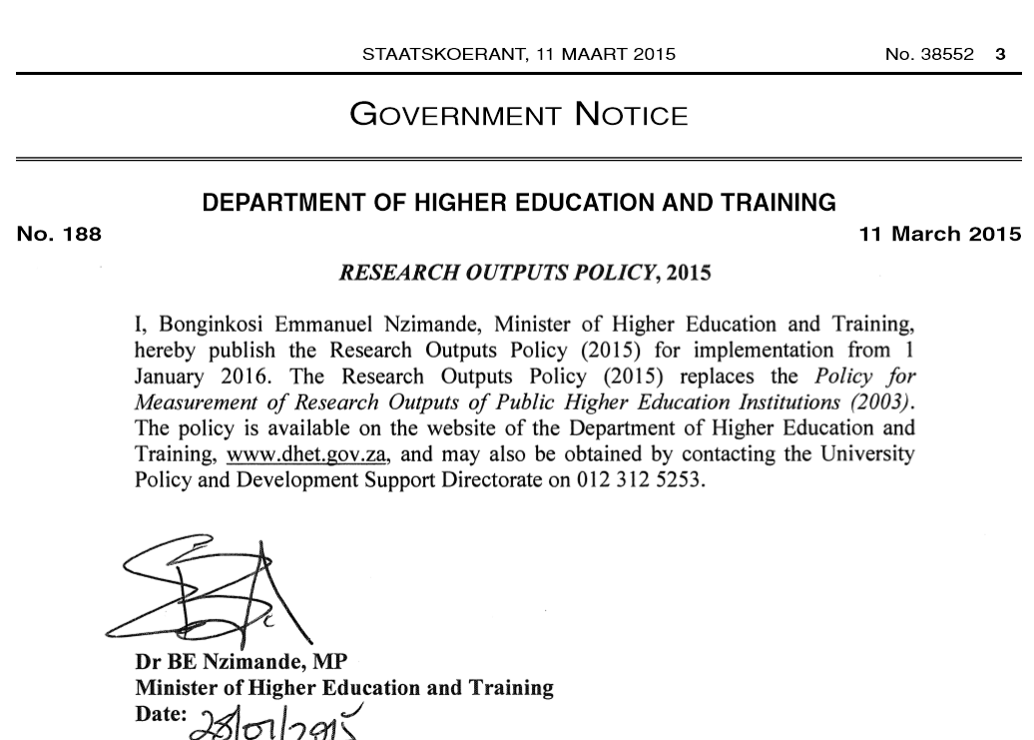

Conference proceedings

- This rule is applicable to national conferences only.

- The 40% is calculated on all papers presented at a particular national conference.

- The 40% will comprise of papers where all the authors on a particular article belong to one institution, for e.g. if there five authors and all are affiliated to UJ, then this must be counted.

- If there are five authors on a paper affiliated to UJ and other HEIs, then this is not counted.

- The 60% contribution from multiple institutions means that no more than 40% of papers must come from any one particular HEI.

- Any HEI’s papers exceeding 40% will render all papers presented at that conference as ‘not-claimable’ for subsidy.

