UJ STRATEGY ON HIV, TB &STI 2019-2024

VISION

To be a Global Centre of Excellence in HIV, TB and STI Management in the
Higher Education Sector

MISSION
Knowledge creation, Mainstreaming and co-ordination of: Teaching, Learning, Research & Community Engagement in
HIV Prevention, Care & Support,
Sexual and Human Rights (SHR) (Advocacy) and
Social Mobilisation

VALUES
IMAGINATION  Shaping the future  Thinking independently  Developing a cosmopolitan identity  Exhibiting ambition and drive  Adopting entrepreneurial approaches | CONVERSATION  Learning together from our diversity  Making wise decisions collectively  Engaging meaningfully with one another  Displaying mutual respect  Leading consultatively
REGENERATION  Developing sustainably through creative contribution  Introspecting for renewal  Innovating for the common good  Making positive change  Taking advantage of overlooked opportunities | ETHICAL FOUNDATION  Treasuring academic freedom  Seeking balance in the pursuit of knowledge  Facing challenges with courage and earning trust  Acting responsibly by being fair, consistent and transparent  Participating in and helping the community (ubuntu)*

2019-2024
STRATEGIC PLAN
CONTENTS
1. Background 1
2. Strategic planning framework 2
3. 2012-2016 strategy review: delivery model 4
4. Risk management 6
5. Environmental scanning 7
5.1 PERSTEL analysis 7
5.1.1 Political influences 7
5.1.2 Economic influences 8
5.1.3 Social influences 8
5.1.4 Technological influences 8
5.1.5 Environmental influences 8
5.1.6 Legal influences 9
5.2 SWOT Analysis 9
5.2.1 Strengths 10
5.2.2 Weaknesses 10
5.2.3 Opportunities 11
5.2.4 Threats 11
5.3 Managerial best practice 12
6. Recommendations and implementation guidelines 13
7. 2019-2024 key focus areas and measurement 16

LIST OF TABLES
Table 3.1: 2012-2016 UJ Performance review 5
Table 5.1: PESTEL Analysis 7
Table 5.2: SWOT Analysis 10
Table 5.3: Managerial best practice 12
Table 6.1: Recommendations and implementation guidelines 13
Table 7.1: 2019-2024 Performance Scorecard 16

LIST OF FIGURES
Figure 2.1: Institutional strategy planning framework on HIV, TB and STI’s Prevention Response 3
Figure 3.1: 2012 – 2016 UJ Key Focus Areas 4
Figure 4.1: Risk management framework (RMF) 6
ACRONYMS
4th Industrial Revolution | = | Industry 4.0.
AIDS | = | Acquired immune deficiency syndrome.
DHET | = | Department of Higher Education and Training.
HCT | = | HIV Counselling and Testing.
HEAIDS | = | The Higher Education HIV and AIDS Programme.
HIV | = | Human immunodeficiency virus infection.
ICT | = | Information, communication and technology.
IOHA | = | Institutional Office of HIV / AIDS.
NSP | = | National Strategic Plan.
PESTEL | = | Political. Economic, Social, Technological, Environmental and Legal influences.
PHC | = | Primary health care.
RMF | = | Risk management framework.
SANAC | = | South African National Aids Council.
SLA | = | Service level agreement.
STIs | = | Sexually transmitted infections.
SCS | = | Student counselling services.
SRC | = | Student Representative Council.
SWOT | = | Strengths, Weaknesses, Opportunities and Threats.
TB | = | Tuberculosis.
UJ | = | University of Johannesburg.
UTT | = | Universal Test and Treat.
WHO | = | World Health Organisation.

1. BACKGROUND

Knowledge, attitudes and practices in Universities about sexuality, gender inequalities and violence against women, youth pregnancy, HIV / AIDS and social justice remain to be amongst the most critical aspects, which could either hinder student success or facilitate their prosperity. Gender inequalities reducing women as subordinates in societies is perhaps one of the fundamental reasons for the sexual abuse of young women at Universities and require urgent attention. In addition, risky behaviours and attitudes by University students will continue unless investments in prevention programmes not only focus on education and awareness but aim to improve the overall student wellbeing and maintain social justice. Hence, to be effective, HIV / AIDS education and prevention programmes must address widespread forms of societal, gender inequalities and the persistence of sexual violence.

In reaction to these challenges, the South African National Aids Council (SANAC) has formulated the 2017-2022 National Strategic Plan (NSP), a master plan outlining the country’s key interventions on responding to the prevention and treatment of HIV and AIDS, tuberculosis (TB) and sexually transmitted infections (STIs). Aligned with the guidelines of the World Health Organization’s (WHOs) on evidence-based Universal Test and Treat (UTT), the NSP includes universal coverage for all people, especially key and vulnerable populations. The Department of Higher Education and Training (DHET) and the collective leadership of the Higher Education sector, have made significant strides on the implementation of a coordinated, comprehensive and effective response strategy to support the national response to HIV and AIDS. The response is following the White Paper for PSET (2013), Transformation Framework for HE (2015), NSP for HIV, TB and STI’s (2017), Adolescent and Youth Policy (2017) and Social Inclusion Policy Framework of PSET (2016). At the core of these strategic frameworks is the eradication of stigma, discrimination, human rights violations and gender inequality by considering the social and structural underpinnings.

UJ’s strategic intent pro-actively formulates and implements strategies that maintain a work, learning and clinical environment that recognises the spread and impact of the disease towards minimising the social, economic and human consequences of the HIV / AIDS epidemic. This ties up with UJ's efforts of embracing the 4th Industrial Revolution (Industry 4.0) and pursuing internationalisation.

Accordingly, UJ, the strategic aims to fulfil an integrated coordinated response where broader issues affecting its community’s sexual and reproductive health, HIV, TB and STI’s, social justice and sexuality will be addressed. This can be achieved through the establishment of offices mandated offices namely IOHA and HR Wellness, forming strategic partnerships with various academic departments to encourage teaching and learning, PHC, Transformation Office, Student Affairs and student counselling services (SCS). IOHA fulfils to coordination role on behalf of the university. Additionally, IOHA and HR Wellness facilitate the implementation of the provision of combination prevention interventions and strategies aimed at reducing new HIV infections and providing holistic service for HIV/AIDS-related matters within the UJ community to fulfil a coordination role of the HIV/AIDS programme.

2. STRATEGIC PLANNING FRAMEWORK

At the core of their strategic mandate, IOHA and HR Wellness aim to facilitate the implementation of the prevention programme and strategies for reducing new HIV infections and providing holistic service for HIV/AIDS-related matters within the UJ community. Together with internal and external stakeholders, they promote HIV Testing Services (HTS), which include Wellness screening, HIV Care and Support for people living with HIV, sexual and human rights and social mobilization. An inside-out perspective was undertaken in the strategic planning process where the external environmental forces where assessed to inform the formulation of the 2019-2024 strategy according to the NSP and related DHET policy frameworks.

Figure 2.1 below depicts the strategic planning framework that underpins the University’s revised approach to the promotion and maintenance of student and employee wellness:

Figure 2.1: Institutional strategy planning framework on HIV, TB and STI’s Prevention Response
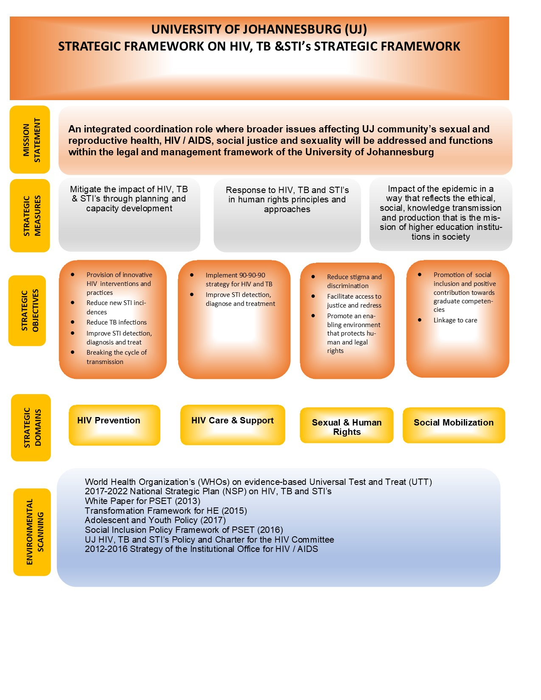
It can be deduced that internal communication structures, student affairs, transformation, employee involvement and culture will play a more critical role in the realisation of the UJ mission. Sections 5.1, 5.2 and 5.3 present a detailed outline of the internal environmental assessment outcomes (PESTEL, SWOT and Managerial Best Practice).

3. 2012-2016 UJ STRATEGY REVIEW: DELIVERY MODEL

While a comprehensive appreciation of the impact of the delivery model remained critical in achieving the set 2012-2016 goals, some indication of success as it currently stands suggests the need for the adoption of a holistically integrated approach. Increasingly, the debate about HIV, TB and STI’s, is no longer about whether to make substantial commitments to prevention, prevalence care and support, but how to implement an integrated framework taking into consideration violence against women, sexuality and social dialogue and justice.
Figure 3.1 below depicts the previous key focus areas used by the university in measuring performance.

Figure 3.1: 2012 – 2016 Key Focus Areas
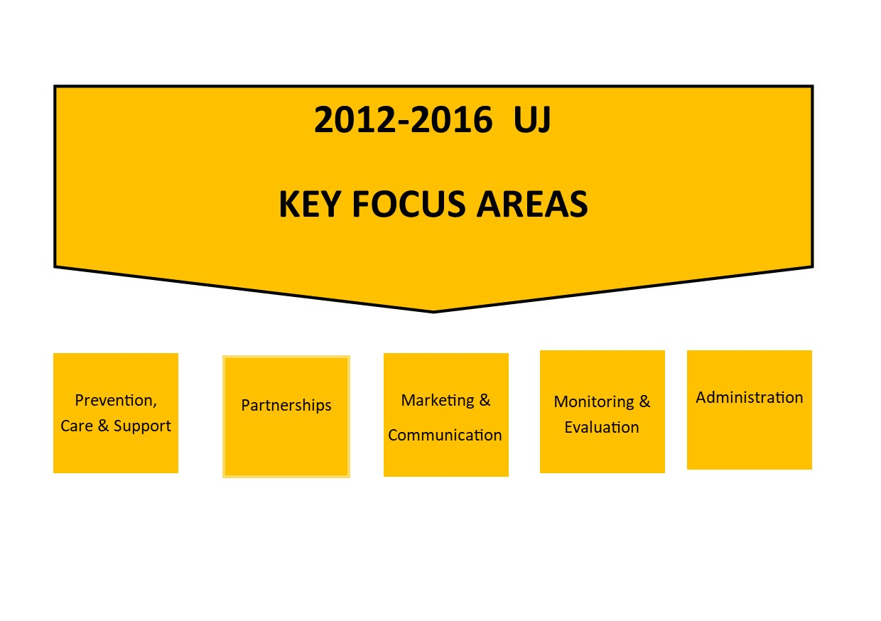

HEAIDS provided the framework for responding effectively to a crisis evident in the higher education environment. The revised policy framework there has to be a conscious shift that provides the requirement for new structural possibilities in the integration of HIV, TB and STI’s response within the holistic health and wellness programme. In an interconnected higher education system, the problems are perhaps symptomatic of more widespread social challenges. The response internationally provides a basis for a more rigorous action. It requires a transformation in thinking on the part of the social impacts considering the University's vision. The incremental challenges and opportunities encourage the University to self-reflect on the strategy policies, and programmes they have in place for dealing with the potential threat of HIV, TB and STI’s prevalence to move swiftly towards the reduction of new incidents.
A 2012 – 2016 performance progress review is outlined in the next page and shows key highlights despite some challenges during the reporting period:

Table 3.1: 2012-2016 UJ Performance review
Measurement domain |  | Interventions and achievements
HIV Prevention |  | - Continued efforts to implemented the carrier Methods.  - Improved the male and female condom distribution
 |  | - Encouraged and improved awareness on circumcision as a preventative measure.
 |  | - Improved awareness campaigns and communication in various platforms and media.
HIV Counselling and Testing (HCT) |  | - Conducted the Condom/STI week in February of the reporting period.  - Facilitated the care month for two weeks in May periodically;  - Staged the HCT/Stigma knockout month in August during the reporting period.  - Conduced the UJ WAD and First Things First Campaign during one week of each September month of the reporting period.
Profiling |  | - Conducted the HIV / AIDS profiling according to gender, level of study, per faculty and for the 1st Time Tester.  - Tracked the profile to understanding how the key indicators affect the population demographics.
HIV Prevalence |  | - Reduced HIV prevalence based on the number tested.  - Improved voluntary testing.  - Increased retention.
HIV Care and support |  | - Enforced linkage to care at UJ or external.
 |  | - Maintained efforts to increase 24hr contact.
 |  | - Facilitated individual and group support.
Peer education |  | - Increased the number per Campus (10 per 10)
 |  | - Intensified the recruitment and retention of peer educators.
 |  | - Improved peer education and training.
 |  | - Conducted work readiness.
Curriculum Integration, Research and Innovation |  | - Improved capacity building interventions for Academic Staff
 |  | - Coordinated student empowerment initiatives.
 |  | - Facilitated the promotion of interfaculty collaboration.
 |  | - Continuously promote collaboration with faculties on HIV/AIDS, TB and wellness research projects attracting subsidy.
Campaigns and Awareness Programs |  | - Maintain the annual schedule of activities.
- Increased collaboration on projects with internal and external partners.
- Increased behaviour change training / programmes projects included HIV activities.
- Facilitated quarterly forums according to schedule.
- Maintained focus on minority groupings, stigma, discrimination and human rights.
- Improved the utilisation of social media to facilitate conversations.
Social Media: Website, Facebook and Twitter |  | - Increased visibility and awareness by advertising on UJ Observer, UJ Radio, U@UJ , Facebook, twitter, IOHA website and other student media for all IOHA events/programs/projects at least two weeks prior to events.  - Recorded the number of articles produced.  - Increased the number of hits on the IOHA website.  - Tracked and improved the number of followers on twitter and Facebook
Leadership footprint |  | - Sustained excellence in HIV & AIDS Committee administration and governance.  - Sustained excellence and committed participation in HIV Committee.  - Facilitated the HIV Committee workshops on a needs basis.  - Established and maintained membership of the Risky Student Behaviour Committee.  - Established and maintained of the Wellness Committee.  - Coordinated the IOHA Departmental meetings.  - Conducted monthly one-on-one discussions with IOHA staff.  - Improved the quality human resource management.  - Maintained sound financial management.
 |  | - Established and maintained internal and external partnerships
 |  | - Global Excellence

4. RISK MANAGEMENT FRAMEWORK

The spectrum of hazards and threats which confront students and employees varies widely and requires the adoption of a dedicated risk management framework (RMF). The RMF is a cyclical process with four cornerstones (focus on HIV, TB and STI’s, sexuality, social justice and gender equality) and it is also underpinned by the three strategic goals (reduce the threat of the spread, mitigate the impact and manage the impact). Activities in the centre of the diagram in Figure 4.1 emphasise the continual feedback loop that ensures that the wellbeing of employees and student receives dedicated actions for reducing the risks:

Figure 4.1: Risk management framework (RMF)
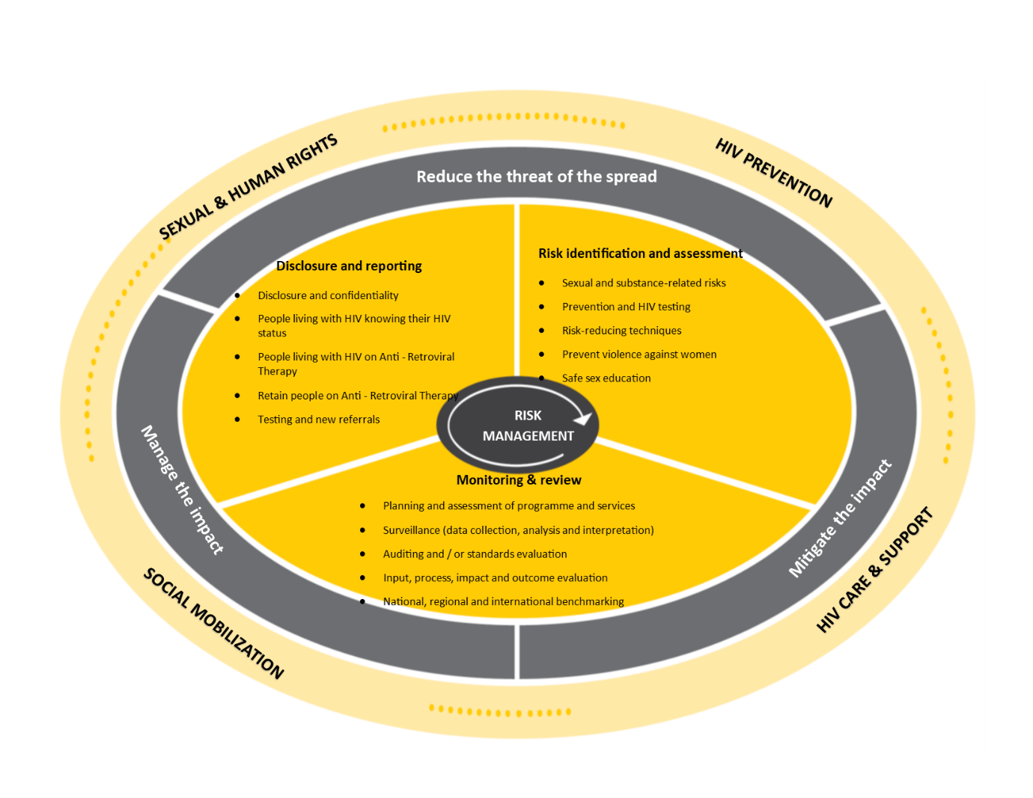

The RMF process will be supported by the implementation matrix in Section 7 articulating planned actions and activities aimed at prevention, care and support. The primary purpose of the RMF is to evaluate the importance of the hazards associated with HIV, TB and STI’s, sexuality, social justice and gender equality for promoting a risk free University environment. The effectiveness of RMF must be measured based on a formal auditing standards and health surveillance to detect failures in risk management. UJ need to be aware of the inherent operational risks in order to make valid risk decisions and place proper emphasis on the allocation of resources, efforts and remedial control measures. Section 5 presents the environmental scanning outcomes used to inform the correct choice of strategic interventions presented in Section 7.

5. ENVIRONMENTAL SCANNING

The RMF process will be supported by the implementation matrix in Section 7 articulating planned actions and activities aimed at prevention, care and support. The primary purpose of the RMF is to evaluate the importance of the hazards associated with HIV, TB and STI’s, sexuality, social justice and gender equality for promoting a risk-free University environment. The expected end result is the success of the UJ HIV, TB and STI’s strategy in terms of the newly adopted key focus areas (gender equality, HIV, TB and STI’s, sexuality and social justice). Proactively accepting changes and exploring new knowledge territories through teaching and learning would enable UJ to effectively respond to the fast changing societal issues. The environmental scanning outcome is presented in Section 5.1 (PESTEL analysis), Section 5.2 (SWOT analysis) and Section 5.3 (Managerial practices).

5.1 PESTEL ANALYSIS

The political (P), economic (E), societal (S), technological (T), environmental (E) and legal (L) considerations are presented in Table 5.1 outlining the potential risks together with the possible action plans UJ can take.
Table 5.1: PESTEL Analysis
5.1.1 | POLITICAL INFLUENCES
TRENDS |  |  | PROPOSED ACTIONS BY CGES
- New political and Student Representative (SRC) landscape. |  |  | - Intensify expectations on optimum HIV, TB, STI’s and wellness approach.
- Increased student, labour and political wildcat unrest. |  |  | - Continuous student and employee engagement.
- Corruption and self-serving leaders in higher education. |  |  | - Demystify the negative publicity through stakeholder engagement.
5.1.2 | ECONOMIC INFLUENCES
TRENDS |  |  | PROPOSED ACTIONS BY CGES
- Increased levels of unemployment resulting in poverty and inequalities. |  |  | - Care and support through partnerships with community engagement, PHC and SCS student.
- Insufficient education and lack of awareness on gender inequality and the effects of social injustice on HIV, TB and STI’s. |  |  | - Intensify HIV, TB and STI’s training with key focus on the eradication of gender inequality and social justice.
- Reduced funding and expenditure affecting the implementation of HIV, TB and STI’s undertakings. |  |  | - Explore creative measures to achieve strategic goals and objectives without attracting more expenditure.
5.1.3 | SOCIAL INFLUENCES
TRENDS |  |  | PROPOSED ACTIONS BY CGES
- Gender inequality and violence against women. |  |  | - Promote actions of gender equality and eradicate violence against women through UJ’s institutional policy guidelines.
- Continued upsurge of discrimination against HIV and TB victims. |  |  | - Optimise campaigns and awareness on building socially-just communities.
- Rise in social injustice. |  |  | - Promote social justice.
- Strong expectation and need for community engagement. |  |  | - Encourage community participation in health programmes such as health information, health education and awareness raising.
5.1.4 | TECHNOLOGICAL INFLUENCES
TRENDS |  |  | PROPOSED ACTIONS BY CGES
- Access to social media and other digital technologies. |  |  | - Investigate much improved electronic communication methods to engage with all stakeholders.
- Open access and electronic platforms with HIV, TB and STI’s data and information. |  |  | - Bring together researchers, clinicians, and technologists and to foster interdisciplinary collaborations on innovative ways to improve HIV, TB and STI’s prevention.
- Technology use may threaten the confidentiality of the HIV, TB and STI’s data and information. |  |  | - Implement ethical and confidentiality policy requirements on the use of mobile applications for HIV, TB and STI’s prevention and care.
5.1.5 | ENVIRONMENTAL INFLUENCES
TRENDS |  |  | PROPOSED ACTIONS BY CGES
- Chronically poor environmental conditions (environmental degradation) or stress (extreme climate events) create conditions which may spread of infectious diseases. |  |  | - Provide stakeholder input towards the protection of resources (including threatened and endangered species, and conservation areas) in interest of promoting measures to prevent HIV, TB and STI’s.
- Diseases interrelated with AIDS (TB and Cancer and opportunistic infections) are all sensitive to weakened immune system. |  |  | - Investigate widespread environmental influences on diseases interrelated with HIV and provide a framework for surveillance, prevalence and monitoring.
- Climate change jeopardizes food security by causing geographical shifts and yield reductions, decreasing water availability. |  |  | - Create and maintaining strategic partnerships investigating the broad sustainability issues, in particular, the impact of climate change on the effective management of HIV, TB and STI’s.
5.1.6 |  | LEGAL INFLUENCES
TRENDS |  |  | PROPOSED ACTIONS BY CGES
- Strong legal and constitutional protection offered to women demonstrates how the adoption of international human rights discourse in addressing violence against women. |  |  | - Establish mechanisms continuously respect human rights and create awareness on the impact of violence against women.
- Prevailing legal, regulatory, trade and other barriers that preventing access to prevention, treatment, care and support. |  |  | - Support DOH on the prioritisation of prevention interventions, provision of care and support as well as teaching and learning.
- South African statutory law is most certainly inclusive of express measures to prevent unfair discrimination. |  |  | - Intensify prohibitions on the existence of unfair discrimination within the University through policy and communication mechanisms.

Overall, the identified environmental influences will enable UJ to provide strong, committed, institutional and societal leadership through the institution’s role of producing graduates, stimulating academic discourse and disseminating new knowledge. On the other hand, UJ should through strategic partnerships promote awareness and access to education, research and curriculum integration, conservation of natural resources, poverty reduction, reducing gender-based violence, and improving health, community and employment systems.
Most importantly, the planned 2019 to 2024 initiatives in Section 4 present the response strategy in dealing with the impact of HIV, TB and STI’s through a coordinated, comprehensive and integrated approach.

5.2 SWOT ANALYSIS

The SWOT analysis presented herein provides an assessment of the internal and external factors affecting the success of UJ based on the strengths and weaknesses for determining whether this information suggests any adaptive approach towards creating a healthy and safe environment within the University that is based on ethical principles, legal norms and human rights. The information may be used to assist the organisation in accomplishing its objectives (opportunity) or overcome or minimise the potential obstacle to achieve desired results (threat) of the university. The higher education environment continues to bear significant changes, and Universities are moving increasingly towards collaboration and interdependence, with more opportunities for best practices in research, pedagogy, and resource sharing. As a result, the initiatives outlined in Section 5 are based on a collaborative approach, highly aligned with University and community expectations, which suggest a new approach and mindsets by the organisation, as the means to inculcate a culture of shared leadership and continuous growth. The strengths (S), weakness (W), opportunities (O) and threats (T) are presented in Table 5.2 below:

Table 5.2: SWOT analysis
5.2.1 | STRENGTHS
FACTORS |  | IMPROVEMENT PRIORITIES
- Key focus on internationalisation and Industry 4.0. |  | - Contribute towards the universities internalisation agenda by improving a culture of prevention, care and support necessary for global excellence.
- Engagement and collaborative culture focused on successful committee. |  | - Maintain ties with all key stakeholders (management, student leadership and communities).
- Competent, motivated, committed, progressive and capable team. |  | - Continuously investigate and provide developmental opportunities.
- Sound institutional reputation attracting both local and international communities. |  | - Foster strategic partnerships by attracting community engagement.
- Capable information, communication and technologies (ICT). |  | - Strengthen the use of social media.
- Quality peer education training programme. |  | - Attract and retain more peer educators to contribute towards testing campaigns.
- Optimal prevention programme. |  | - Improve the condom distribution, HCT Campaigns, etc.
5.2.2 | WEAKNESSES
FACTORS |  | REMIDIAL PRIORITIES
- Ineffective use of social media. |  | - Implement strategies and initiatives to fully optimise the social media.
- Unclear strategic mandate leading to the implementation of ineffective and inefficient services. |  | - Strategically position departments to optimise shared resources in partnership with PHC, SCS and other stakeholders.
- Lack of strategic partnership and collaborations. |  | - Improve communication and collaborative relationships with all key stakeholders.
- Lack of effective organisational structure leading to inefficient service. |  | - Reorganise the unit into an integrated structure including the PHC and SCS.
- Lack of a governance framework with noncompliance risks. |  | - Initiate and implement processes to develop policies and procedures, SLA’s, process flows and other resources to improve governance.
- Weak HIV / AIDS curriculum integration efforts. |  | - Strengthen partnerships with academics and increase awareness to teaching and learning.
- Reduced budgets and funding. |  | - Investigate and implement cost-contained initiatives.
5.2.3 | OPPORTUNITIES
FACTORS |  | OPTIMISATION PRIORITIES
- National and international awareness of the health and wellness departments. |  | - Investigate initiatives to profile thedepartments as the credible unit of excellence.
- Establish departmental synergies and collaborative relationships to share resources. |  | - Strategic partnerships with PHC, SCS and other stakeholders.
- Intensify efforts towards curriculum integration. |  | - Partner with academics to publish peer reviewed journal articles on related matters.
- Scale up awareness on HIV Prevention programme and HCT campaigns. |  | - Design focused-prevention interventions and attractive HCT campaigns.
5.2.4 | THREATS
FACTORS |  | MITIGATION PRIORITIES
- Decrease in the financial budget. |  | - Investigate and implement cost-contained initiatives.
- Continued acts of discrimination, gender violence and inequality. |  | - Strengthen communication on non-discrimination and social integration.
- Increased tensions due to student political activities. |  | - Improve relationships with student representative structures.
- Low staff morale and lack of career advancement opportunities. |  | - Investigate employee engagement strategies to improve the morale of staff and implement the Individual Development Plans.

The SWOT analysis outcome indicates the need for improved ways of governance and hence the establishment of the health and wellness departments will reduce the threats and minimise weakness. The University’s response to the pandemic has over the years focused on (1) prevention, care and support, (2) partnerships, (3) marketing and communication and (4) monitoring and evaluation. While these priorities remain critical, it is becoming more critical to incorporate principles of gender equality and social justice with more rigour.
This concerns going back to basics by embracing the slogan that: “Umuntu ngumuntu ngabantu” translated into English as “I am because you are; you are because we are”. The slogan involves qualities of cooperation, supportiveness, togetherness or solidarity in responsive and proactive wellness programmes. The university acknowledges that one unit does not exist in a vacuum, but is interdependent and interconnected with numerous parts of the University. Hence the strategy to leverage these relationships as well as the University’s institutional knowledge to deliver optimum value. A key opportunity identified herein is about established departmental synergies and collaborative relationships to share resources. This will be achieved by articulating an incremental approach recognising that there will be different operational challenges, reporting capacities and stakeholder pressures.

5.3 MANAGERIAL BEST PRACTICE

Part of the environmental scanning was to consider the internal managerial practices as the means through which value can be derived by the university. Five (5) key managerial best practices were identified and the list below provides interventions for consideration:

Table 5.3: Managerial best practice
MANAGERIAL BEST PRACTICE | 1. | INTEGRATED STUDENT AND EMPLOYEE WELLNESS APPROACH
- Maintain a culture of prevention, care and support through:
- Reduction of the transmission through awareness initiatives for decreasing the spread of infection within the University and outside communities;
- Protecting and promoting the health of students and increase workplace employee wellness;
- Provision of acceptable standard of healthcare equivalent to that available in the communities, including preventive measures, without discrimination;
- Address any form of inequalities.
 | 2. | RESPECT FOR HUMAN RIGHTS
- Respecting the rights of those at risk of or living with HIV and TB by developing and implementing policies and programmes consistent with international human rights norms.
- Adherence to international standards and health guidelines through a clearly articulated response programme.
- Manage vulnerability, stigma, and discrimination.
 | 3. | EVIDENCE-BASED INTERVENTIONS
- Develop and implement policies and programmes based on empirical evidence
- Apply scientifically proven evidence to create awareness and reduce the risks of HIV, TB and STI’s transmission and improving the health of UJ community
 | 4. | COLLABORATIVE AND INCLUSIVE COOPERATION
- Cooperation and collaborative action that integrates the mandates and responsibilities of various stakeholders.
- Encourage joint-partnership on non-discrimination in employment, gender equality, screening and confidentiality, social dialogue, comprehensive prevention, care and support.
 | 5. | MONITORING AND QUALITY CONTROL
- Identify appropriate metrics or indicators to monitor the successful implementation of HIV, TB and STI’s and wellness interventions.
- Regular reviews and quality control assessments including independent monitoring the general University premises for compliance
- Provide comprehensive health services in the process of restoring and maintaining good livelihood of students and employees.

A holistic student and employee wellness approach envision creative and innovative programmes through strategic partnerships for maintaining social justice. Information sources considered in Section 6 yielded useful trends to adopt for implementing an integrated approach.

6. RECOMMENDATIONS AND IMPLEMENTATION GUIDELINES

In consideration of the environmental scanning outcomes identified in Section 5, it is recommended that UJ consider a comprehensive view of performance implications to adopt appropriate recommendations. Table 6.1 below presents the proposed recommendations and implementation guidelines:

Table 6.1: Recommendations and implementation guidelines
RECOMMENDATIONS | PERFORMANCE IMPLICATIONS |  | PROPOSED PLANNED INTERVENTIONS
Servant and  ethical  leadership | - | Health standards and University conditions may be compromised due to lack of the appropriate leadership. | - | Implement effective policies and strategies by obtaining leadership commitment.
 | - | Acknowledge that high risk behaviours for the transmission of HIV, TB and STI’s occurs within the University affecting PHC. | - | Strengthen legal compliance and ethical obligations, rather than opinion or political expediency.
Legislative  and  policy reform | - | The primary responsibility for respecting, protecting and fulfilling human rights obligations, including the right to enjoy the highest attainable standard of health. | - | Forge strategic partnerships (internal and external) to influence legislative and policy reforms beneficial to the prevention of HIV, TB and STI’s and promoting employee wellness.
 | - | International and national legislative and policy frameworks have the potential to promote or impede progress in reducing HIV transmission in institutions of higher learning. | - | Enforce compliance with applicable legislation and maintain the human rights principles concerning the right to PHC and access to services.
Living conditions in the University residences | - | Sub-standard living conditions can increase the risk of HIV transmission through sexuality, sexual coercion, and rape. | - | Enforce security within the University’s residential areas and campuses to monitor and combat acts of intimidation, victimisation, sexual harassment and rape.
 | - | Sub-standard living conditions such as unhygienic and unsanitary environments have a negative impact on the health of students living with HIV and TB can increase their exposure to infectious diseases such as tuberculosis and hepatitis. | - | Maintain hygienic and sanitary residential and campus environments with ZERO risk to health hazards which may affect people living with HIV and TB and expose employees, visitors and students to environmental risks.

Funding  and  information resource allocation | - | In order to effectively address the range of challenges that HIV/STI’s, sexuality, gender equity and social justice poses within campuses, it is imperative to secure sustained resources necessary to develop and implement comprehensive, evidence-based interventions. | - | Consider the increased healthcare expenditure and explore national as well as international funding opportunities to address HIV, TB and STI’s, sexuality, social injustice and gender inequality. Furthermore, obtain additional financial resources to produce healthcare for meeting the increased demand for services.
 | - | In spite of the ongoing efforts, resource allocation remains key in driving awareness and prevention. Information resources may be limited and lack currency, relevance and appropriateness. Hence a communication strategy must consider various options. | - | Resources such audio-visuals, pamphlets, vertical files, leaflets, posters, newspapers, books and social media are important for awareness and maintaining effective communication. The selection of these media should be prioritised based on activity objectives.
Continued, prevention, care, treatment and support | - | The structure and management of the University’s health services have the potential to promote or impede progress towards the objective of prevention, care, treatment and support. | - | Provide students and employees without discrimination with access to healthcare including preventive measures equivalent to or more than that provided by the Government.
 | - | Reduction in the spread of HIV, TB and STI’s in Universities and caring for those who are infected remain a critical of continued critical thinking. | - | Maintain compliance with international obligations by continuing and facilitating healthcare services of international standard.
Comprehensive  and  accessible HIV/AIDS healthcare services | - | Providing employees and students with the knowledge about HIV, TB and STI’s infection and providing effective care, treatment and support. | - | Implement comprehensive HIV, TB and STI’s prevention and education, HIV testing services, HIV, TB and STI’s care and treatment with stakeholder involvement for ensuring comprehensive and integrated approach.
 | - | Beyond HIV, TB and STI’s risks, students and employees are exposed to environmental changes and social influences with implications for their health and other aspects of wellbeing. Moreover, creative ways need to be explored for creating access to services. | - | Identify constraints to accessing healthcare services and implement measures that will promote successful prevention, care and support. UJ must facilitate comprehensive access to healthcare by ensuring the optimal supply and utilisation of services by students and employees.
Student  and  employee training | - | HIV, TB and STI’s has implications for the professional duties and responsibilities of administrative and academic staff at the University and for workplace safety and security. | - | Provide employees and students with full access to the prevention measures, care, treatment, and support in the University at all times.
 | - | Employee education and support is essential to create optimal conditions in ensuring a safe and healthy environment for students, visitors and themselves for promoting access to healthcare services and increasing attempts to reduce the HIV, TB and STI’s prevalence. | - | Targeted prevention, support and informative education programmes must be carried out with key focus on behavioural research, HIV testing services, respect for human rights, and effects of substance abuse, gender equity, sexuality, distribution and utilisation of protective materials.
Evidence-based practice | - | Effective and ethical public health practice mandates that policies and programmes to promote health and prevent disease transmission be based on an objective assessment and on empirical evidence leading to the effectiveness of the interventions. | - | Implement policies and programmes based on the needs of the student and staff and on evidence-based as well as evaluated models of good practice considering that the outcomes of these assessments must be properly evaluated.
 | - | The interdisciplinary approach ensures knowledge transfer beyond borders of disciplines which is key towards teaching and learing in evidence-based HIV, TB and STI’s education. | - | Strengthen interdepartmental collaborations for obtaining collective input in view of developing acceptable ethical standards of good practice in curriculum integration leading to evidence-based knowledge creation.
International, regional, and national collaboration | - | Sharing and disseminating international, national, and regional experience is essential to the promotion of effective and evidence-based responses. | - | Knowledge and expertise on effective management of HIV, TB and STI’s must be shared both nationally and internationally and that the development of evidence-based practices are enhanced by building upon the successes of other countries and jurisdictions
 | - | Teaching and learning internally and across international borders has the potential to present useful insights on the optimisation of the UJ service. | - | Adopt acceptable ethical standards of good practice in teaching and learning through collective interdepartmental collaborations and take the lead in international, regional, and national collaboration.

The abovementioned recommendations must be considered in the context of the key focus areas, namely, gender equality, HIV / AIDS, social justice and sexuality. The last part of this plan in Section 7 presents the newly adopted Performance Scorecard aligned with the strategic framework in Section 2.

7. 2019-2024 PERFORMANCE SCORECARD

The performance scorecard below indicates how UJ seeks to achieve its strategic objectives based on the four (4) domains of measurement. The goals and targets set hereunder require leadership, partnerships and the allocation of resources to fulfil a coordinated and monitoring role following the NSP and related DHET policy frameworks. Also, functions within the legal and management framework UJ.

Table 7.1: 2019-2024 Performance Scorecard
Objective 1: Prevention of HIV, TB and STIs

NSP Strategic goals | UJ Strategic objectives | Inputs | Indicators and Targets (Output)
- Accelerate prevention  In order to reduce new HIV and TB infections and new STI’s (Breaking the cycle of transmission) | - Provision of innovative HIV interventions and practices that are informed by research and results in an increased uptake of HTS  - Reduce new STI incidences  - Reduce TB infections through screening, diagnose and referrals  - Improve STI detection, diagnose and treat  - Breaking the cycle of transmission through provision of barrier methods that cater for male, female and people with diverse sexual orientation and MMC | - Medical Prevention:  - Know where students & staff test project  - Screening of students and staff on HIV, STI and TB  - Barrier methods  - Educate and promote MMC  - Access to PrEP  - Initiating and adherence to ARV’s | - Conduct an annual testing survey  - Provide provider and client initiated HIV testing services  - Number of barrier methods distributed  - Refer to accredited service provider identified and contracted  - Link to treatment initiation site and followed up for adherence  - Collect data and report
Objective 2: HIV, TB and STI’s Care and Support

NSP Strategic goals | UJ Strategic objectives | Inputs | Indicators and Targets (Output)
- Reduce Illness and death by providing treatment care and adherence support for all ( 90-90-90 in every district) | - Implement 90-90-90 strategy for HIV and TB  - Improve STI detection, diagnose and treatment | - HIV Care and Support Programme  - Access to ART on campus  - Number of students referred for individual and/or group counselling (those who consented) by External Testing Service Providers  - Number of students referred for individual and/or group counselling (those who consented) by UJ HIV Counsellors and Primary Health Care  - Increase detection of TB and STI  - Referral for treatment and care | - Number of Students and Staff tested : Test a minimum of 30% of the population at each campus  - Referral forms  - Monitor lost to follow up  - Monthly Reports
Objective 3: Sexual and Human Rights

NSP Strategic goals | UJ Strategic objectives | Inputs | Indicators and Targets (Output)
5. Ground Response to HIV, TB and STI’s in human rights principles and approaches (Equal treatment and social justice) | - Reduce stigma and discrimination affecting people with HIV, TB and STI’s  - Facilitate access to justice and redress for people with and vulnerable to HIV and TB  - Promote an enabling environment that protects human and legal rights | - Focus on minority groupings, stigma, discrimination and human rights  - % of marginalised community who report stigma and discrimination | - Conduct annual index survey to determine number of people experiencing internal and external stigma i.e. LGBTQI+, PWD, PWHIV  - Facilitate campaigns to eradicate stigma e.g. Annual Social Inclusion sports challenge, dialogues, debates and Pride  - Social inclusion sensitisation training  - Establish data base for vulnerable and key populations
Objective 4: Social Mobilization

NSP Strategic goals | UJ Strategic objectives | Inputs | Indicators and Targets (Output)
- Reach all key and vulnerable populations with comprehensive customised and targeted interventions ( No one left behind) | - Seek to promote social inclusion and contribute positively towards the students ‘graduateness’  - Link students and staff to needs specific health and wellness services | - Innovative inclusive programmatic approach of Campaigns, events, teaching and learning  - Regular activities (calendar events)  - Other campus events – (collaborate projects increased with internal and external partners)  - Implement social behaviour change projects, events, teaching and learning programmes  - Innovative methods of communication | - No of innovative activities  - Inclusion of second curriculum to contribute positively towards graduate competencies through: Peer education, internships, student assistants, workshops, dialogues  - Communication in the 4 IR era: Building successful partnerships in addressing pertinent student issues through dialogue, events, online conversation, drama, live streaming and conferences  - Attendance registers and reports of attendance  - Surveys  - No of students tested  - Feedback reports and analysis after each campaign
Objective 5: Partnerships

NSP Strategic goals | UJ Strategic objectives | Inputs | Indicators and Targets (Output)
4. Address social and structural drivers of HIV, TB infection and STI’s (Multi-department, multi-sector approach) | - Strengthen, maintain and establish Internal partnerships  - Strengthen, maintain and establish  - external partnerships  - Address RSB through:  - Identify themes that define RSB to  - facilitate a coordinated and  - collaborated approach in  - addressing them  - Advocating for a better institutional structure on issues relating to behaviour that puts students at risk by:  - Promoting Healthy Leaving  - Planned Interdepartmental collaboration  - Address identified issues of concern for students  - Asset based approach: Achive positive change using students and staff own knowledge, skills and lived experience of the issues they encounter in their own lives  - Advise the MEC on RSB related matters | - Advocate for a better institutional structure on issues relating to behaviour that puts students at risk Intentional and unintentional risk:  - Violence: traffic safety, suicide and related behaviours.  - Substance abuse  - Sexual behaviour  - Nutrition, dietary and physical activity  - Hygiene  - Collaborate projects increased with internal and external partners | - Number sustainable partnerships and collaborations with :  - Internal departments  - Faculties  - Student societies  - IOHA Alumni  - Number sustainable partnerships and collaborations with :  - Government departments  - NGO’s  - Cooperate sector  - HEI’s
Objective 6: Leadership

NSP Strategic goals | UJ Strategic objectives | Inputs | Indicators and Targets (Output)
6. Promote Leadership at all levels and shared accountability for a sustainable response to HIV, TB and STI ( Mutual accountability) | - Strengthen HIV Committee to provide effective coordination and leadership  - Facilitate shared accountability for implementing the NSP and UJ HIV, TB and STI strategy | - Annual performance score card  - Support and academic departments participating in the committee  - Involvement of external partners i.e. Civil Society, NGO’s and Government departments involved | - Number of meetings per year and progress reports  - Number of departments participating in the HIV response strategy  - Number of external partners involved
Objective 7 : Resource Mobilization

NSP Strategic goals | UJ Strategic objectives | Inputs | Indicators and Targets (Output)
7. Mobilise resources to support the achievement of NSP goals and ensure a sustainable response (Spend now save later) | - Promoting access to financial and human resources in supporting initiatives | - Allocated budget by University  - % of budget sourced other than University | - 100% utilization  - 10%
Objective 8: Monitoring and Evaluation

NSP Strategic goals | UJ Strategic objectives | Inputs | Indicators and Targets (Output)
8. Strengthen strategic information to drive progress towards achievement of NSP goals (Data driven action) | - Monitoring and Evaluation of implementation and interventions by various departments  - Effective utilization of data to strengthen interventions | - Completed M& E Strategic Document  - Continuous review of assessments and data tools utilised  - Monthly and Quarterly reports  - Standardise Information Management system  - Compile and review Customer Satisfaction Surveys/ Data tools  - Archive documents with accredited service provider | - Updated Strategy  - Customer Satisfaction Surveys (85%)  - Information Management System

