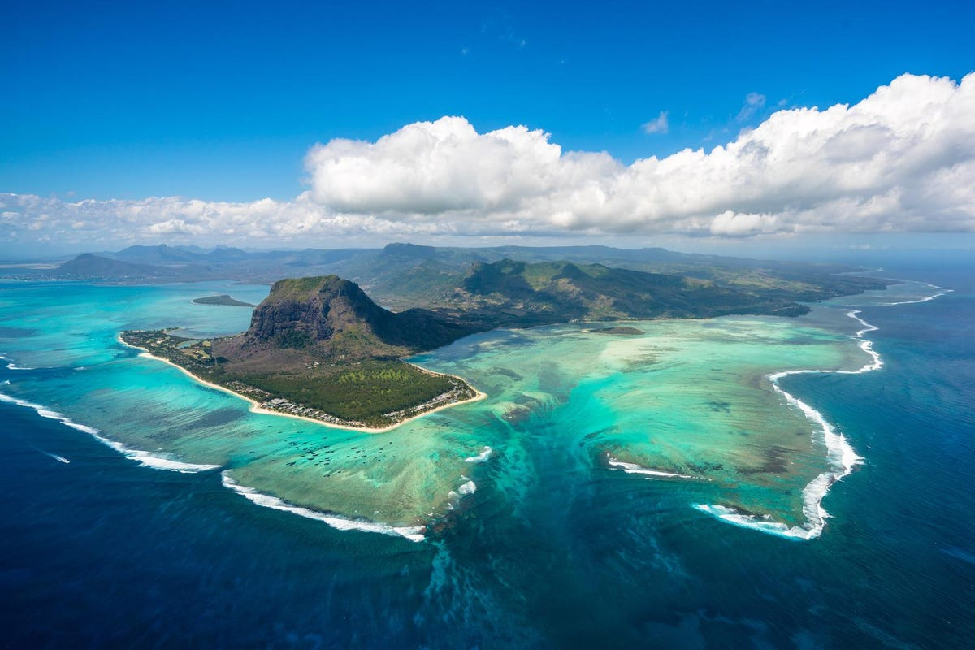

|  |  |  |  |  |  |  |  |  |  |  |  |  |  |  |  |
| --- | --- | --- | --- | --- | --- | --- | --- | --- | --- | --- | --- | --- | --- | --- | --- |
| 1. **Who can apply?**  * South African citizens in good health and with an excellent academic record, * Candidates must have an interest in studying in Mauritius and demonstrate a commitment to the development of South Africa, * Candidates must be available to study in Mauritius at the start of their academic programme in October 2022, * All applicants must meet the entry criteria for their selected programme in Mauritius, * All applicants must meet the minimum academic requirement for entry into a similar programme at a South African University, * All candidates must have proficiency in English, * Not be in receipt of a scholarship from any other public source in Mauritius, * Applicants must have already applied for full-time on-campus studies at any public Higher Education Institution in Mauritius for the academic year starting in 2022 (proof of application is required by 31 July 2022), * Awardees should be vaccinated against COVID-19 to have access to higher education institutions in Mauritius. * For awardees who cannot be vaccinated, for medical purposes they will be required to produce duly certified medical certificates. * Applicants must be prepared to undergo a medical check-up as per the Passport and Immigration Office requirements (http://passport.govmu.org), in Mauritius and the test results shall be submitted to the Passport and Immigration Office, with a copy to the Ministry, not later than one month after arrival in Mauritius.  1. **Scholarship Offers**  * Tuition fees and course-related costs of up to MUR 100 000. * A monthly living allowance to the value of MUR 12 500 (approximately R4 500). * Students will be entitled to free basic health care in public hospitals in Mauritius. * Return airfare to and from Mauritius by the most economical route.     **Closing date:**  Applications for 2022 open on **30 May 2022 and close on 31 July 2022.** All documents should reach Ms Jacky Smit and Mr Sello Tlhatlha before or on the closing date. | 1. **Application Process**   All applicants for the scholarship must have already applied for at least one full-time on-campus programme at a public higher education institution of their choice in Mauritius. Either a conditional offer or proof of application or an acknowledgment of application from a Mauritian HEI must be submitted together with the scholarship application.  Application for university admission must be made as soon as the Mauritius institutions have opened their application windows on their respective websites. The following documents **MUST** accompany the completed application form:   * Certified copy of the birth certificate, * Certified copy ID and biodata page of the passport. * Certified copies of all post-school qualification certificates and all post-school academic transcripts. * Copy of letter of conditional offer by a public Higher Education Institution in Mauritius (if available at time of application) OR proof of application/ copy of acknowledgment notices from a Mauritian public HEI that the application has been made and the appropriate application fee has been paid. Due date 31 July 2022. * Proof of payment of application fees. * All postgraduate (Master’s and Ph.D.) applications must attach a 1-2 page research plan, including research aims and objectives, methodology, and social relevance of the proposed study. Please refer to the guidelines for information about the study plan.   **All documents submitted must be clear and in PDF format (no photographs of documents will be accepted).**   1. **Applications for the October 2022 intake may be made at any of the following institutions:**  |  |  |  |  | | --- | --- | --- | --- | | **Institution** | **Tentative Application Window** | | **Website** | | **Open** | **Closes** | | University of Technology, Mauritius | May 2022 | **31 July 2022.** | [www.utm.ac.mu](http://www.utm.ac.mu) | | Université des Mascareignes | May 2022 | **31 July 2022.** | [www.udm.ac](http://www.udm.ac). | |
|  |  |

The Government of Mauritius is offering scholarships to eligible South Africans for full-time, on-campus undergraduate and postgraduate programmes tenable in public Higher Education Institutions (HEIs) in Mauritius for the 2022 academic year starting in October 2022. The Mauritius – Africa Scholarship Scheme invites applications for scholarships for postgraduate MSc and PhD for 2022. The Department would like to invite eligible applicants who wish to further their studies and pursue careers in the identified scarce skills to apply for the MSc and PhD level-study offered by the Mauritius – Africa Scholarship Scheme. The information below is for South African applicants only.