ATTENTION: News editors
Media Release
Wednesday 20 July 2022

Announcement of the winners of the
2022 UJ Prizes for Creative Writing in isiZulu
2022 UJ Prizes for Creative Writing in Sesotho sa Leboa
2022 UJ Prizes for Literary Translation

The University of Johannesburg is pleased to announce the winners of the following three newly instated prizes: UJ Prize for Creative Writing in isiZulu, UJ Prize for Creative Writing in Sesotho sa Leboa, and the UJ Prize for Literary Translation.

Ntombenhle Protasia Dlamini and Khanyelihle Mnguni have been named joint winners of UJ's main prize for creative writing in isiZulu in 2022 – Dlamini for her work Zinoju Zulu and Mnguni for Kusazoba Mnandi. Congratulations!

The anthology Zinoju Zulu by NP Dlamini consists of 60 poems in isiZulu written in a rich poetic language. Various themes are examined, including those related to education, caution, tradition, and modernity.
One of the adjudicators commented that Mnguni’s collection, Kusazoba Mnandi, “contains 16 short stories dealing with different themes presented in relation to social life, airplanes, witnesses, COVID-19, lesbianism, killing of taxi owners and fights amongst the politicians.”

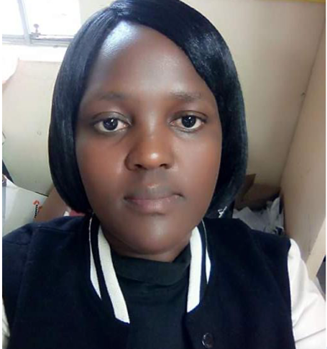
Ms Ntombenhle Dlamini

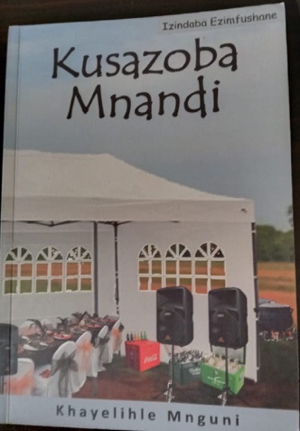 | 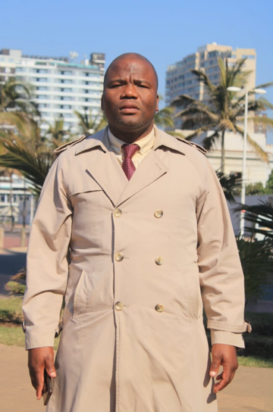
Mr Khayelihle Mnguni

A huge congrats to Sandile Ngwenya, winner of the 2022 UJ Debut Prize for Creative Writing in isiZulu for Imali Yezipoki.

This debut novel for young adults is the story of Sgegede who digs up his late grandfather's buried treasure of Kruger rands and converts it into cash, thus unlocking a series of events. The novel is described as “African magical realism and a rural-urban thriller” (Clarke’s Bookshop, Cape Town). Ngwenya was also awarded first prize in the 2021 Sanlam Prizes for Youth Literature Competition for Imali Yezipoki.

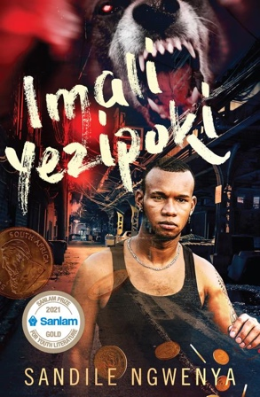 | 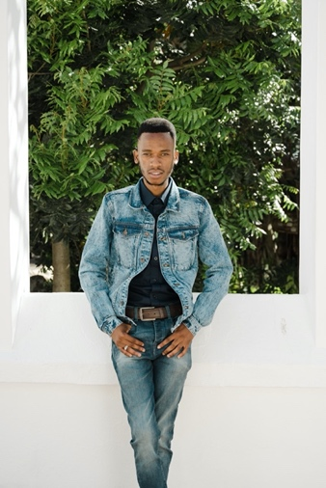
Mr Sandile Ngwenya

Ms Nomusa Sibiya from UJ’s Multilingual Language Services Office was the coordinator of the isiZulu prizes. She also served on the panel of adjudicators together with Dr Brenda Bokaba and C W Mthembu.

It is with great joy that we announce the winner of the 2022 Sesotho sa Leboa main prize as Ditsakauma Tša Marumo by PM Mashilo & MT Masha.

The panel emphasised that other writers should be inspired by the use of Sesotho sa Leboa's standard form. Additionally, they recognised that a wide variety of genres are included, such as fairy tales, riddles, proverbs, idioms, poems, and songs, and commended the authors for a well-written work that enriches Sesotho sa Leboa.

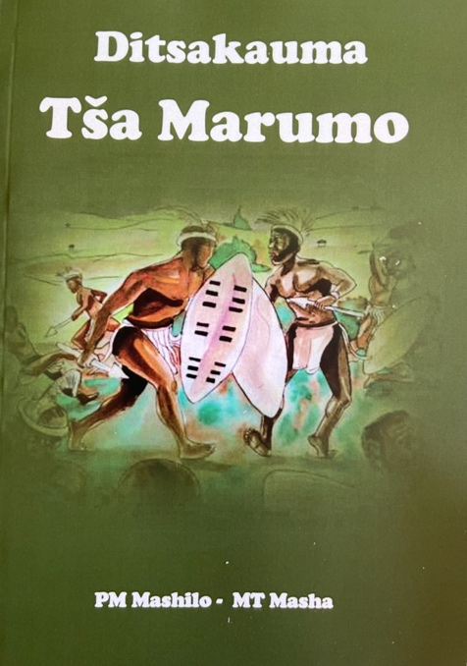 | 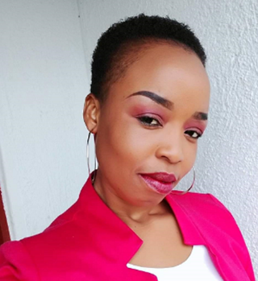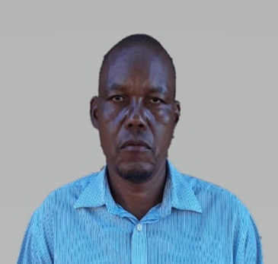
Ms Mplang Masha Mr Phineas Mashilo

Congratulations to the joint winners of the 2022 UJ Debut Prize Creative Writing in Sesotho sa Leboa – Kholofelo Thaba for Sedibeng sa Komelelo and Mahlatsi Maqwenjo for Bohlale bjo foufetšego.

The panel praised Thaba's use of Sesotho sa Leboa as a poetic language that permeates Sedibeng sa Komelelo. The poet successfully uses proverbs, idioms, and other poetic devices to express themes about pandemics, natural disasters, love, and more.

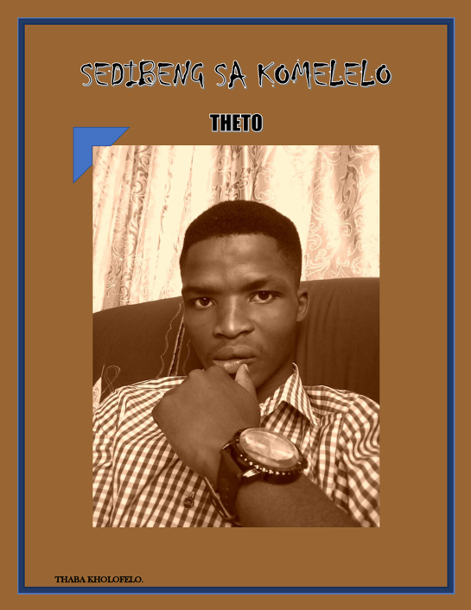
Mr Kholofelo Thaba

The theme of Maqwenjo’s novel Bohlale bjo foufetšego is summarised in the saying ‘ngwana magana go botšwa o wetše dikomeng…’ equivalent to ‘As you make your bed, so you must lie on it’. In this book, the author uses language, characters, and plot to illustrate how life choices can have different consequences.

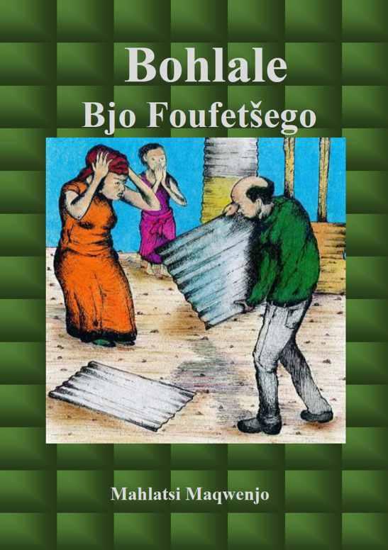 | 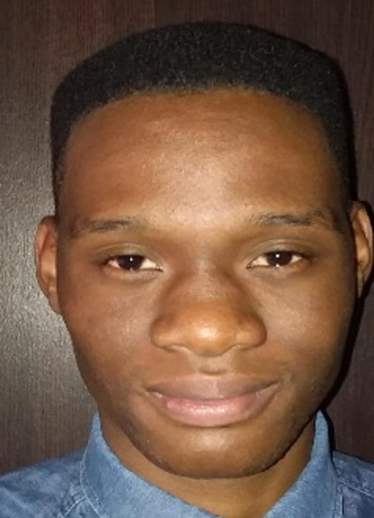
Mr Mahlatsi Maqwenjo

Mr Moroamofo Leshilo from UJ’s Multilingual Language Services Office was the coordinator of the Sesotho sa Leboa prize. He also served on the panel of adjudicators together with Ms Nthabi B Malatji and Mr Maropeng Maponya.

A sincere congratulations goes to SJ Naudé, who was named the winner of the 2022 UJ Prize for Literary Translation for his self-translation of Dol heuning into English from the original Afrikaans.

Panellists addressed the author/translator's translation and commented specifically on the author’s “total command of the source text and the freedom to adjust that text to the demands and resources of the target language. Thus, in this case, we have at times a meticulously faithful translation, and at times a slightly more adventurous translation.”

In SJ Naudé's collection of short stories, every line is masterfully crafted, and it is up to a capable translator to do justice to every word. It is part literal translation, but there are certain parts that are translated in a less literal manner and are moved away from the original Afrikaans. In both cases, it enriches the reading experience.

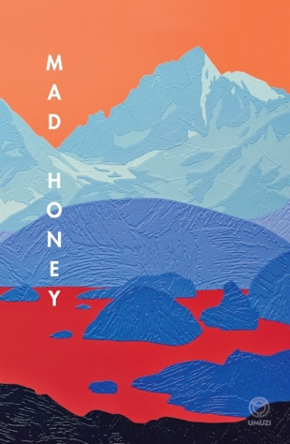 | 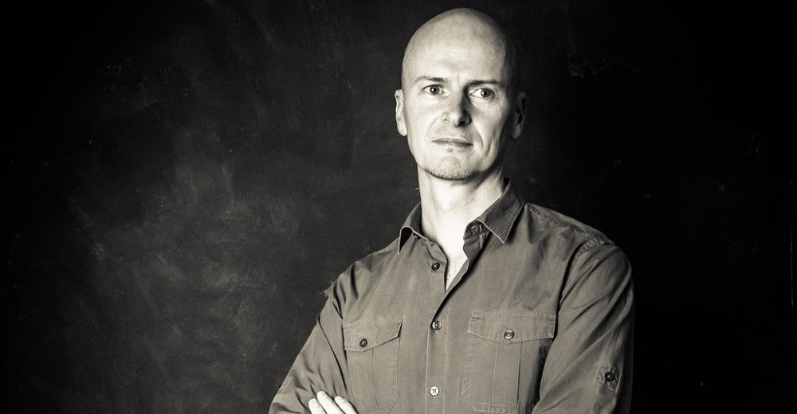
SJ Naudé

Prof Marné Pienaar acted as the coordinator of the Translation prizes. Together with Prof Pienaar, Ms Corné Johl and Prof Michiel Heyns served on the panel of adjudicators.

These prizes are administered by the Multilingual Language Services Office (MLSO) of the University of Johannesburg. Ms Corné Johl is available for interviews on request and can be contacted directly on 071 453 3461 or at cornej@uj.ac.za.

